SUPERSTITIONS

TASK 1 – Reading comprehension
Read the text below and answer the questions in short note form.
SUPERSTITIONS
(Adapted from: https://www.ktb.gov.tr/EN-98631/superstitions.html, https://theconversation.com/the-science-of-superstition-and-why-people-believe-in-the-unbelievable-97043.)
Many superstitions stem from the same human trait that causes us to believe in monsters and ghosts. Superstitions cannot be explained. The 2010 study found that superstitions could sometimes work, because believing in something can improve performance on a task.

Although there is no single definition of superstition, it generally means a belief in supernatural forces – such as fate – the desire to influence unpredictable factors and a need to resolve uncertainty. In this way then, individual beliefs and experiences drive superstitions, which explains why they are generally irrational and often defy current scientific wisdom.
There is a certain amount of unreasoning beliefs among people living in a community, arising sometimes from fear, sometimes from helplessness, and sometimes from coincidences. And we call these superstitions. These beliefs have been existing since the creation of the first human being. Great number of them are not related with any scientific basis, reason, contemporariness and religious faith. Although they have nothing to do with wisdom and reason, unfortunately they could not be removed and eliminated from heart, brain, conscience of human being. In emerging of such kind of beliefs both natural structure of persons and illiterate words of elderly persons, as well as of some religious officials have been effective. Even if beliefs have shown variation from person to person, they have also some common aspects.
Psychologists, who have investigated what role superstitions play, have found that they derive from the assumption that a connection exists between co-occurring, non-related events. For instance, the notion that charms promote good luck, or protect you from bad luck.
For many people, engaging with superstitious behaviours provides a sense of control and reduces anxiety – which is why levels of superstition increase at times of stress. This is particularly the case during times of economic crisis and social uncertainty – notably wars and conflicts.
Here is a list of most known superstitions.
The number 13, black cats, breaking mirrors, or walking under ladders, may all be things you actively avoid.
Even if you don’t consider yourself a particularly superstitious person, you probably say “bless you” when someone sneezes, just in case the devil should decide to steal their soul – as our ancestors thought possible during a sneeze.
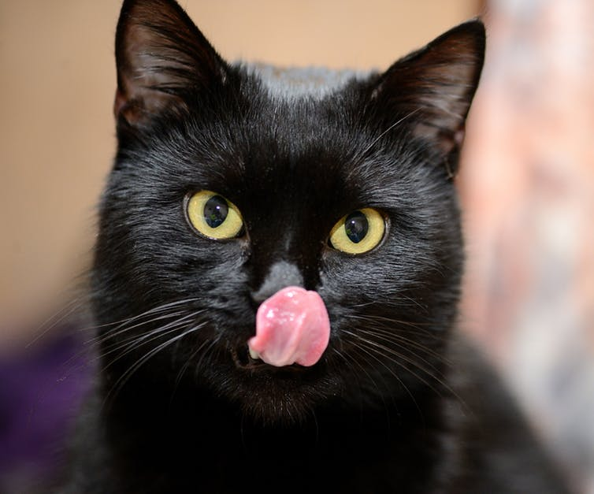
Superstition also explains why many buildings do not have a 13th floor – preferring to label it 14, 14A 12B or M (the 13th letter of the alphabet) on elevator button panels because of concerns about superstitious tenants. Indeed, 13 % of people in one survey indicated that staying on the 13th floor of a hotel would bother them – and 9 % said they would ask for a different room.
On top of this, some airlines such as Air France and Lufthansa do not have a 13th row. Lufthansa also has no 17th row – because in some countries – such as Italy and Brazil – the typical unlucky number is 17 and not 13.
Source: https://theconversation.com/the-science-of-superstition-and-why-people-believe-in-the-unbelievable-97043
Black cats are less likely to be adopted. Does superstition play a part?

- Where do many superstitions stem from? ______________________________
______________________________________________________________

- Can superstitions be explained? ____________________________________

- What does the word “superstition” mean? _____________________________
______________________________________________________________
______________________________________________________________

- Since when have these beliefs been existing? __________________________
______________________________________________________________

- According to psychologists, where do these beliefs derive from? ____________
______________________________________________________________

- What do these beliefs provide for many people? ________________________
______________________________________________________________

- List the most known superstitions. ___________________________________
______________________________________________________________
TASK 2 – Dictionary work
Look up the underlined vocabulary items in the English-English dictionary and make a meaningful sentence with each of them.
___________________________________________________________________
___________________________________________________________________
___________________________________________________________________
___________________________________________________________________
___________________________________________________________________
___________________________________________________________________
___________________________________________________________________
___________________________________________________________________
___________________________________________________________________
___________________________________________________________________
___________________________________________________________________
___________________________________________________________________
___________________________________________________________________
___________________________________________________________________
___________________________________________________________________
___________________________________________________________________
___________________________________________________________________
___________________________________________________________________
___________________________________________________________________
___________________________________________________________________
___________________________________________________________________
___________________________________________________________________
___________________________________________________________________
___________________________________________________________________
___________________________________________________________________
___________________________________________________________________

TASK 3 – Listening skills
Listen to Stevie Wonder's song entitled Superstition
https://www.youtube.com/watch?v=0CFuCYNx-1g
and fill in the missing words.
SUPERSTITION by Stevie Wonder

Very superstitious, writings on the wall
Very superstitious, ____________ bout' to fall
____________ month old baby, broke the lookin' glass
____________ years of bad luck, the good things in your past
When you believe in things that you don't ______________
Then you ____________
Superstition ain't the way
Very superstitious, wash your ___________ and ___________
Rid me of the problems, do all that you can
Keep me in a _______________, keep me goin' strong
You don't want to save me, sad is my song
When you believe in ______________ you don't understand
Then you suffer
Superstition ain't the way, yeh, yeh
Very superstitious …

(Source: https://www.azlyrics.com/lyrics/steviewonder/superstition.html)

Which two unlucky omens can you find in the song? (They are meant to be unlucky in the Western culture.)

TASK 4 – Speaking skills

What do you think is Stevie Wonder's attitude towards superstitions? You can find his opinion in the box bellow.

What has Stevie Wonder said about the song?
“I think that the reason that I talked about being superstitious is because I really didn’t believe in it. I didn’t believe in the different things that people say about breaking glasses or the number 13 is bad luck, and all those various things. And to those, I said, ‘When you believe in things you don’t understand, then you suffer.’”
Stevie
Source: https://genius.com/Stevie-wonder-superstition-lyrics

Answer the questions:
- Name some of the most common superstitions spread among the people in your country.
- What is your attitude towards superstitions?
- Are you superstitious yourself?
TASK 5 – Speaking skills: comparing pictures
Compare and contrast the following two pictures:

Source: http://psychiclibrary.com/beyondBooks/ladder-superstition/

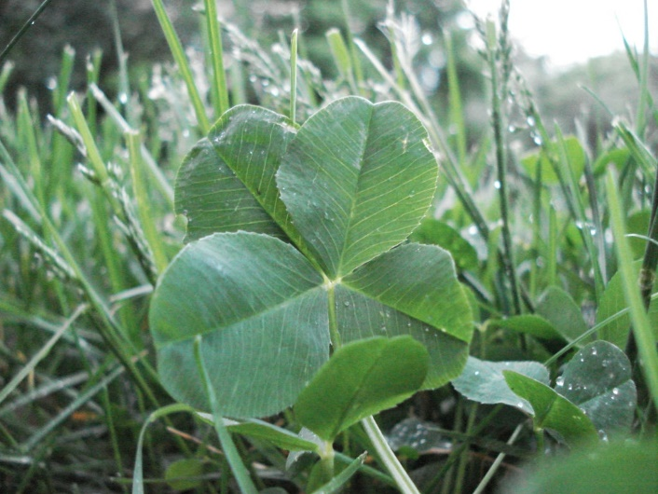
Source: https://www.instructables.com/id/4-leaf-Clovers%253a-A-Finder-s-Guide/

TASK 6: Word formation
Complete the following text with the correct form of the words in brackets.
10 COMMON SUPERSTITIONS
(Source: https://www.everydayhealth.com/healthy-living/10-common-superstitions/)
If you’d like to know why it’s bad luck to walk under a ladder or to cross paths with a black cat, read on for the back story to some of the most common superstitions.
But these and other common superstitions _______________ (typical) have a _______________ (colour) history that dates back centuries.
And while some superstitions may be just for fun, others might affect you enough to influence the choices you make. Many superstitions have deep roots in a culture’s tradition and history.
1. Friday the 13th: Bad Luck
Many of us can’t help feeling a bit of trepidation when we realize another Friday the 13th is coming up.
A fear of the number 13 is one of the most common superstitions around; it’s so widespread that many tall apartment buildings and hotels simply omit labelling their 13th floor. And have you noticed that some airlines don’t have a 13th row?
One version of the origin of this superstition is that Judas Iscariot was the 13th guest at the Last Supper and Jesus was crucified on Friday.
Put that together and you have one unlucky day of the year.
2. Itchy Palm: Good Luck
There are many variations on this superstition. But the idea of having an itchy palm ________________ (general) refers to someone who is _______________ (greed) or has an insatiable desire for money.
In Shakespeare’s Julius Caesar, Brutus says, “Let me tell you, Cassius, you yourself are much condemned to have an itching palm.”
Some believe that if the right palm itches you will meet someone new, while an itchy left palm means that money is coming.
Others say that an itchy right palm means money coming in and a left-handed itch foretells money going out.
The superstition warns you not to scratch your palm unless you want to counteract the effect. The only way to scratch it without stopping the effect is to use lucky wood or brass.
3. Walking Under a Ladder: Bad Luck
It’s common sense to avoid walking under an open ladder for fear of something falling on you, but there are superstitious reasons for _______________ (avoid) ladders too.
The shape of an open ladder is a triangle, which signifies life in some mythologies.
When you walk through the triangle, it’s thought that you tempt the Fates. You also run the risk of awakening spirits that live within the triangle, including evil spirits who may not be happy with the disturbance.
If you do ______________ (accident) walk under a ladder, you can counteract the bad luck by placing your thumb between your index and middle fingers and holding it for at least 5 seconds, or cross the fingers of both hands while calling upon the sign of the cross to protect you from evil.
4. Breaking a Mirror: Bad Luck
Many superstitious people say breaking a mirror sets you up for 7 years of bad luck. That may be because 7 years is the time it takes to replace all the cells in your physical body.
In a more superstitious time, mirrors were thought to be reflections of the soul. So breaking a mirror was believed to be ______________ (harm) to the soul.
To end the chain of bad luck, take the broken mirror outside and bury it in the moonlight.
5. Finding a Horseshoe: Good Luck
In many cultures, a horseshoe is the luckiest of all symbols, especially if you find one with the open end pointing toward you.
If you find one of these good-luck charms, pick it up with your right hand, spit on one end, make a wish and toss it over your left shoulder. Then leave it where it lands.
Or place a horseshoe over the ______________ (enter) to your home with the open ends up. This allows the horseshoe to fill with good luck for everyone living there.
One superstitious belief says the number of nails left on an abandoned horseshoe reveal how many years of good luck are coming your way.
6. Opening an Umbrella Inside: Bad Luck
It seems like a no-brainer that opening an umbrella inside brings bad luck, since it presents a risk of breaking ______________ (value) items and poking someone in the eye.
But one common superstition holds that because umbrellas shade us from the sun they’re somehow magical.
When the umbrella is opened inside – out of the way of sun’s rays – it offends the sun god.
It may even signify impending death or ill fortune for both the person who opened it and the people who live within the home.
7. Knock Twice on Wood: Reverse Bad Luck
The origin of this well-known superstition dates back to a time when some cultures believed that gods lived in trees. To ask the gods for a favour, people would lightly tap the bark of the tree.
Then, to say thank you when the favour was granted, a person would knock lightly again on the same tree.
This custom may have also originated with Christians ____________ (offer) thanks for good fortune with this gesture to Jesus Christ, who died on a cross made from wood.
8. Tossing Spilled Salt Over Your Shoulder: Good Luck
For most of human history, salt has been very ____________ (value); in some places and times, it was worth its weight in gold. One common superstition held that it could purify the soul and ward off evil spirits.
So, when you spill any amount of salt, you ought to take a pinch and toss it over your left shoulder.
By doing this, the superstition says, you drive away any evil spirits attracted to the spill who may want to cause misfortune for the unlucky spiller.
9. Black Cats: Bad Luck
This superstition is a tough one for cat ______________ (love) to swallow, but in the Middle Ages it was thought that witches kept black cats as companions.
Some people even believed that these kitties could turn into witches or demons after 7 years.
_______________ (power) men like Hitler and Napoleon Bonaparte may have been prepared to conquer nations, but both were terrified of a black cat.
10. Saying “God Bless You”: Good Luck
For some, it’s good manners, pure and simple; but blessing someone after he or she sneezes is actually a common superstition.
In 6th century Europe, people congratulated anyone who sneezed; they believed the person was expelling evil spirits.
Early Romans believed that a strong sneeze could release your soul into the world and a “bless you” would keep it safely at home.
When the Black Plague hit Europe in 1665, the pope required everyone to be blessed when they sneezed. He believed that a sneeze was a sign the person would _____________ (like) die soon.
The blessing was usually followed up by making the sign of the cross, for good measure.
Common superstitions still have a place today. After all, you never know when a simple action to counteract bad luck will make you and those around you a little bit luckier.

TASK 7 – Writing skills

Write an essay giving your opinion on the following statement:
Illiterate and weak-minded people are a prey to superstitions.

How far do you agree with this statement? Support your opinion in 160–180 words.

ILLITERATE AND WEAK-MINDED PEOPLE ARE A PREY TO SUPERSTITIONS
___________________________________________________________________
___________________________________________________________________
___________________________________________________________________
___________________________________________________________________
___________________________________________________________________
___________________________________________________________________
___________________________________________________________________
___________________________________________________________________
___________________________________________________________________
___________________________________________________________________
___________________________________________________________________
___________________________________________________________________
___________________________________________________________________
___________________________________________________________________
___________________________________________________________________
___________________________________________________________________
___________________________________________________________________
___________________________________________________________________
___________________________________________________________________
___________________________________________________________________
___________________________________________________________________
___________________________________________________________________
___________________________________________________________________
___________________________________________________________________
___________________________________________________________________
___________________________________________________________________
___________________________________________________________________
___________________________________________________________________
___________________________________________________________________
___________________________________________________________________
___________________________________________________________________
___________________________________________________________________
___________________________________________________________________
___________________________________________________________________
___________________________________________________________________
___________________________________________________________________
___________________________________________________________________
___________________________________________________________________
___________________________________________________________________
___________________________________________________________________
___________________________________________________________________

