SCIENCE AND TECHNOLOGY

TASK 1 – Reading comprehension

Read the article and complete the gaps with the words from the box.

fluctuations destruction destructive fragments important hurricanes processes sediment hemispheres collaborators layers scientists eruptions government average circulation storms inactivity periods

IN THE BLUE HOLES OF THE BAHAMAS, SECRETS OF HURRICANES PAST
(Adopted from: https://www.nytimes.com/2019/11/01/science/blue-holes-hurricanes.html, New York Times, Nov. 1, 2019, by Katherine Kornei.)
Katrina. Harvey. Maria. Dorian. In recent years, ________________ have killed thousands of people and caused billions of dollars in damage. But getting a handle on how frequently these _________________ storms have pummeled the planet is tough because records stretch back only about a century and a half.
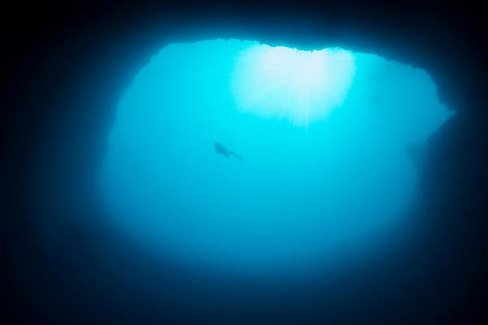
Now, researchers have assembled a 1,500-year history of hurricanes in the Bahamas, based on sand and shell ___________________ pulled up from submarine caverns known as blue holes. Their results, published in October in Paleoceanography and Paleoclimatology, show that hurricane activity has varied over time. In fact, recent hurricane activity in the Bahamas has been low compared with historical highs, despite intense activity elsewhere in the Atlantic arena. The ____________________ are likely driven by changes in atmospheric and oceanic circulation and volcanism, the scientists suggest.
Blue holes, a type of sinkhole in the Bahamas, are revered among divers for their deep, clear waters. (Source: https://static01.nyt.com/images/2019/11/05/science/01TB-BLUEHOLES1/01TB-BLUEHOLES1-jumbo.jpg?quality=90&auto=webp)
In the aftermath of Hurricane Dorian and the _________________ it caused in parts of the Bahamas, this historical record is “a wake-up call, said Lisa Kennedy, a geographer at Virginia Tech who was not involved in the research. “We are only beginning to understand hurricane patterns and _________________ in the context of long-term history.”
Blue holes form when carbonate rock erodes, collapses and fills with water; they are revered among divers for their deep, clear waters. They are also _________________ keepers of the scientific record, as hurricanes wash coarse material like sand, gravel, shells and pieces of coral into them.
“I can immediately look at it and say, ‘There’s a hurricane layer,’” said Lizzie Wallace, a paleoclimatologist in the Massachusetts Institute of Technology/Woods Hole Oceanographic Institution Joint Program in Oceanography.
In 2014, Ms. Wallace’s colleagues collected _________________ cores from the bottom of blue holes on South Andros Island.
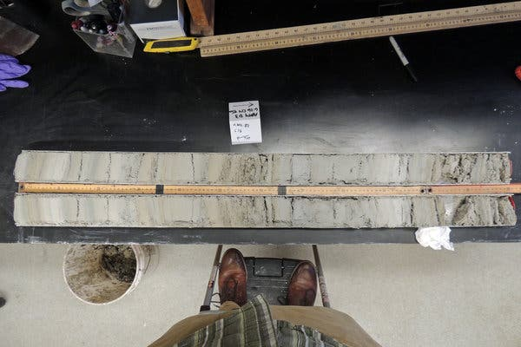
Back at Woods Hole, the team used radiocarbon dating to date the ages of mangrove leaves they found scattered within the cores. By interpolating between these age markers, Ms. Wallace and her ________________________ estimated when each layer of hurricane-transported debris was deposited. They focused on 51 layers in their longest core record — nearly 60 feet long — from a blue hole called AM4. The oldest layer was deposited around 500 A.D.
A sediment core from South Andros Island contains sandy __________________ left behind by ancient hurricanes. (Source: https://www.nytimes.com/2019/11/01/science/blue-holes-hurricanes.html)
Hurricane activity in the Bahamas has been far from constant, Ms. Wallace and her team showed. For example, storms were frequent from the 7th to the 9th centuries — more than six occurred per century, on _________________. But most of the 19th century was quiet; the researchers found no hurricane debris dating from roughly 1840 to 1915.
“We found these active and quiet intervals,” Ms. Wallace said.
These cores don’t capture every hurricane, the __________________ noted. Rather, they reflect only the most intense storms, those with winds exceeding 111 miles per hour, or stronger than Category 3 on the Saffir-Simpson Scale, that pass within about 30 miles of South Andros Island.
These periods of relative activity and ____________________ appear in core records from other places like the Gulf of Mexico, said Jeffrey Donnelly, a paleoclimatologist at Woods Hole Oceanographic Institution and Ms. Wallace’s thesis adviser. “It suggests not randomness but some broader-scale climatic forcing.”
Changes in atmospheric and oceanic ___________________ and volcanism are possible culprits, the researchers suggest.
The Intertropical Convergence Zone, the region in the tropics where trade winds from the northern and southern ___________________ converge, drives convection that can kick-start a hurricane. If the zone shifts north, more hurricanes will be recorded at northern latitudes.
Volcanic ________________ can also have an effect by pumping out aerosols that cool the planet. Cooler ocean surface temperatures have been linked to reduced hurricane activity.
Only two hurricanes appear in the South Andros Island cores since 1851, the year the U.S. _________________ started keeping records. That average frequency, of just over one hurricane per century, is far lower than in previous _______________, said Dr. Donnelly. “Much of the last 1,500 years has been much more active than anything we’ve seen in the last hundred.”
If the past is an indicator of the future, this lull will be temporary, the researchers suggest. And, they add, an uptick in hurricane activity will affect more than just the Bahamas: Many of the _________________ that strike the Caribbean continue on to hit the Gulf of Mexico.

TASK 2 – Dictionary work

Look up the words in bold type in the English-English dictionary and make a meaningful sentence with each of them.

NEUROSCIENCE
Sleep may trigger rhythmic power washing in the brain
(Adapted from: https://www.sciencenews.org/article/sleep-may-trigger-rhythmic-power-washing-brain, ScienceNews, October 31, 2019, by Laura Sanders.)

Every 20 seconds, a wave of fresh cerebrospinal fluid rolls into the sleeping brain. These slow, rhythmic blasts, described for the first time in the Nov. 1 Science, may help explain why sleep is so important for brain health.
Studies on animals have shown that the fluid, called CSF, can wash harmful proteins, including those implicated in Alzheimer’s disease, out of the brain. The new results give heft to the idea that a similar power wash happens in sleeping people.
Researchers studied 13 healthy, young people in an MRI scanner as they fell into non-REM sleep, the type of slumber that takes up most of the night. At the same time, the scientists monitored different sorts of activity in participants’ heads. Electrodes measured the activity of large collections of nerve cells, and functional MRI measured the presence of oxygenated blood that gives energy to those nerve cells. By using a form of rapid fMRI, the team also measured another type of activity — the movements of CSF in the brain.
Fast fMRI revealed waves of fresh CSF that flowed rhythmically into the sleeping brains, a pattern that was obvious — and big, says study co-author Laura Lewis, a neuroscientist and engineer at Boston University. “I’ve never had something jump out at me to this degree,” she says. “It was very striking.”
During non-REM sleep, blood (colored red) flows out of the brain just before a wave of cerebrospinal fluid (blue) rolls in, entering from a lower part called the fourth ventricle. That cerebrospinal fluid may help clean harmful proteins out of the brain.
Awake people have small, gentle waves of CSF that are largely linked to breathing patterns. In contrast, the sleep waves were tsunamis. “The waves we saw during sleep were much, much larger, and higher velocity,” Lewis says.
Dno obrazca
Those CSF waves were tied to other types of waves in the brain, the researchers found. First, a slow wave of nerve cells’ electrical activity — the sort that indicates non-REM sleep — sweep the brain. Then, levels of oxygen in the brain’s blood fall, representing an outflow of blood. And finally, possibly to take the place of the exiting blood, the wave of CSF rolls into the brain.
The study “elegantly links a number of seemingly unrelated topics in neuroscience, including sleep, brain waves, cerebrospinal fluid flow and blood flow, together,” says Maiken Nedergaard, a neuroscientist at the University of Rochester Medical Center in New York.
It’s not yet clear exactly how the various waves are related to each other. Lewis and her colleagues plan on testing whether one event causes the others.
Spotting these powerful CSF waves in the sleeping brain raises the possibility that they may clear harmful waste products from the brain (SN: 7/15/18). Nedergaard and her colleagues have found that CSF coming into mice’s brains can carry away amyloid-beta, a sticky protein that accumulates in Alzheimer’s disease. When mice are asleep, more CSF comes into their brains, and more amyloid-beta gets cleared away, her studies suggest. Finding an influx of CSF in sleeping humans “is really a significant move,” Nedergaard says.
Studying the strong CSF waves in people with Alzheimer’s disease might reveal new aspects of the disorder, Lewis says. Slow waves of nerve cells’ electrical activity during sleep are known to decline with age, and the decline is particularly severe in people with Alzheimer’s disease. That decline, Lewis says, could mean that the CSF waves are diminished in these people, too, an absence that could leave more toxic proteins sticking around.

___________________________________________________________________
___________________________________________________________________
___________________________________________________________________
___________________________________________________________________
___________________________________________________________________
___________________________________________________________________
___________________________________________________________________
___________________________________________________________________
___________________________________________________________________
___________________________________________________________________
___________________________________________________________________
___________________________________________________________________
___________________________________________________________________
___________________________________________________________________
___________________________________________________________________
___________________________________________________________________
___________________________________________________________________
___________________________________________________________________
___________________________________________________________________
___________________________________________________________________
___________________________________________________________________
___________________________________________________________________
___________________________________________________________________
___________________________________________________________________
___________________________________________________________________
___________________________________________________________________
___________________________________________________________________
___________________________________________________________________
___________________________________________________________________
___________________________________________________________________
___________________________________________________________________
___________________________________________________________________

TASK 3 – Listening and speaking skills
Throughout sports, technology has changed the face of performance. Listen carefully to David Epstein’s talk on sporting achievements over the last decades
https://www.ted.com/talks/david_epstein_are_athletes_really_getting_faster_better_stronger?referrer=playlist-the_most_popular_science_talks
and then summarise it pointing out the most important factors mentioned.

TASK 4 – Speaking skills

Compare and discuss the following two pictures:

(Source: https://www.google.si/search?q=science+pictures&tbm=isch&source=iu&ictx=1&fir=WT-DtCqCiB15FM%253A%252C4mzKaP8IVGeCaM%252C_&vet=1&usg=AI4_-kSvbx0rrO9cfkSOCUaWY9PrCGftlg&sa=X&ved=2ahUKEwiqleavx8vlAhVrlIsKHTK9AOYQ9QEwA)
(Source: https://www.google.si/search?q=science+pictures&tbm=isch&source=iu&ictx=1&fir=WT-DtCqCiB15FM%253A%252C4mzKaP8IVGeCaM%252C_&vet=1&usg=AI4_-kSvbx0rrO9cfkSOCUaWY9PrCGftlg&sa=X&ved=2ahUKEwiqleavx8vlAhVrlIsKHTK9AOYQ9QEwA)

TASK 5 – Word formation

Complete the following text with the correct form of the words in brackets.

ENGINEERS DEVELOP A NEW WAY TO REMOVE CARBON DIOXIDE FROM AIR
(Adopted from: https://www.engineersjournal.ie/2019/11/04/engineers-develop-a-new-way-to-remove-carbon-dioxide-from-air/, Massachusetts Institute of Technology, October 25, 2019, by David L. Chandler)

A new way of __________________ (remove) carbon dioxide from a stream of air could provide a significant tool in the battle against climate change. The new system can work on the gas at __________________ (virtual) any concentration level, even down to the roughly 400 parts per million __________________ (current) found in the atmosphere.
Most methods of removing carbon dioxide from a stream of gas require higher concentrations, such as those found in the flue __________________ (emit) from fossil fuel-based power plants. A few variations have been developed that can work with the low concentrations found in air, but the new method is ___________________ (significant) less energy-intensive and expensive, the researchers say.
The technique, _______________ (base) on passing air through a stack of charged electrochemical plates, is described in a new paper in the journal Energy and Environmental Science, by MIT postdoc Sahag Voskian, who developed the work during his PhD, and T. Alan Hatton, the Ralph Landau Professor of Chemical Engineering.
The device is __________________ (essential) a large, specialized battery that absorbs carbon dioxide from the air (or other gas stream) passing over its electrodes as it is being charged up, and then releases the gas as it is being discharged. In operation, the device would simply alternate between charging and discharging, with fresh air or feed gas being blown through the system during the charging cycle, and then the pure, concentrated carbon dioxide being blown out during the discharging.
"This binary affinity allows capture of carbon dioxide from any __________________ (concentrate), including 400 parts per million, and allows its release into any carrier stream, including 100 percent CO2," Voskian says. That is, as any gas flows through the stack of these flat electrochemical cells, during the release step the captured carbon dioxide will be carried along with it. For example, if the desired end product is pure carbon dioxide to be used in the ___________________ (carbon) of beverages, then a stream of the pure gas can be blown through the plates. The captured gas is then released from the plates and joins the stream.

TASK 6 – Writing skills
Write an essay in 180–200 words discussing the following topic:

BENEFITS OF SCIENCE AND TECHNOLOGY
___________________________________________________________________
___________________________________________________________________
___________________________________________________________________
___________________________________________________________________
___________________________________________________________________
___________________________________________________________________
___________________________________________________________________
___________________________________________________________________
___________________________________________________________________
___________________________________________________________________
___________________________________________________________________
___________________________________________________________________
___________________________________________________________________
___________________________________________________________________
___________________________________________________________________
___________________________________________________________________
___________________________________________________________________
___________________________________________________________________
___________________________________________________________________
___________________________________________________________________
___________________________________________________________________
___________________________________________________________________
___________________________________________________________________
___________________________________________________________________

