ENVIRONMENT / NEW TECHNOLOGY
Task 1 – Reading comprehension
Read the text and match the words on the left to their explanations on the right:
1. __ absorbing | a) cover, often made of light material
2. __ blinds | b) you put this over windows to stop the sun getting in
3. __ canopy | c) that is not heavy
4. __ convert | d) achieving maximum productivity with minimum wasted effort or expense
5. __ emissions | e) that can take the weight of something
6. __ lightweight | f) change something into something else
7. __ panel | g) a flat thing, you can put it on a roof
8. __ efficient | h) the production of gas, e.g. carbon dioxide
9. __ source | i) something you get energy from
10. __support | j) taking in

Task 2 – Reading comprehension
Answer the following questions referring to the text on solar power:
1. What is the most ancient power source in our solar system? ___________________
2. What do we need to find in order to reduce the amount of carbon dioxide that we put into the atmosphere? __________________________________________________
3. Where can traditional PV panels only be used on? __________________________
___________________________________________________________________
4. Where can the solar cloth be installed? ___________________________________
___________________________________________________________________
5. What do the canopies provide and what do they help charge? __________________
___________________________________________________________________
6. What is perovskite? __________________________________________________
7. What did Professor Henry Snaith from Oxford University prove? ________________
___________________________________________________________________
8. What has been one of the big problems of solar power? ______________________
9. How much world's energy does the solar power produce at the moment?
___________________________________________________________________
10. List the three ideas that might change our world forever. ________________
___________________________________________________________________

Solar-powered future
(Adapted from the article in Teen – Your English Monthly, November 2015.)
The sun is the most ancient power source in our solar system. Researchers and businesses across the world are developing cheaper and more efficient ways of using all that free energy from the sun.
We are at the start of new, green industrial revolution. We need to find cost-effective and practical ways to reduce the amount of carbon dioxide that we put into the atmosphere. Solar power is going to be a big part of that. At the moment, the UK is installing more photovoltaic, or PV, panels than anywhere else in Europe.
Traditional PV panel (which are made up of many solar cells) can only be used on roofs that are strong enough to support their weight. The solution? A flexible, lightweight solar “cloth”! This solar cloth can be installed on existing buildings such as factories, warehouses and supermarkets. There are about 800 million square metres of these lightweight roofs in the UK. The material can also be used on canopies in car parks – the Solar Cloth Company believes there are at least 350 million square metres of car parking in the UK. These canopies not only provide shade but can even help charge your electric car. The material could be used on clothes to charge phones, in window blinds to power lighting and on sails to provide for yachts.
Professor Henry Snaith from Oxford University was one of the first people to prove that a mineral called perovskite was great at absorbing solar energy. It is cheap and easy to produce and will help make solar cells much more efficient. It can be painted onto special glass, which could turn skyscrapers into vertical power stations! Professor Snaith believes this new technology could completely change the way the world makes electricity from sunlight.
One of the big problems of solar power has been cost. Prices are going down every year, but the technology is still quite expensive. In addition, most PV panels will only last for about 25 years and they are only around 20 % efficient, which means they are only able to convert about 20 % of the energy they receive from the sun into electricity. There's a long way to go! At the moment, solar power produces about 1 % of the world's energy.
We're just at the start of the solar revolution! Here are some ideas that might change our world forever.
SolaRoad is the first road in the world that converts the sun's energy into electricity. It's an idea from Holland and so far the 100-metre experimental road has created enough energy for a single person for a year.
Solar Paper is the world's thinnest and lightest solar charger. It's so thin you can carry it inside a notebook or you can attach it to a backpack if you are out hiking or walking. It's in the development phase at the moment.
Solar Impulse is the first solar-powered plane. This plane, developed in Switzerland, has broken the record for the longest flight using sunlight. In July 2015, it flew non-stop from Japan to Hawaii, that's a distance of 7,200 km! They've had some technical difficulties with batteries, but the team hope to finish flying all the way round the world very soon.

Task 3 – Word formation
Write the correct form of the words in the brackets:
1. The _______________ (reduce) of the carbon emissions is needed.
2. We're at the start of a new, green _____________ (industry) revolution.
3. ______________ (effect) and _______________ (practice) ways to reduce the amount of carbon dioxide need to be found.
4. The article offers some _______________ (innovation) ideas from the UK.
5. _________________ (tradition) PV panels are made up of many ___________ (sun) cells.
6. This solar cloth can be installed on _________________ (exist) buildings such as factories, supermarkets and warehouses.
7. New technology could _________________ (complete) change the way the world makes electricity from sunlight.
8. In ____________________ (add), most PV panels will only last for about 25 years.
9. The 100-metre ___________________ (experiment) road has created enough energy for a single person for a year.
10. It's the world's __________________ (thin) and lightest solar charger.

Task 4 – Listening and speaking skills
Watch the following videoclip “How We Turn Solar Energy Into Electricity” and express your opinion about solar panels, which are becoming cheaper and more efficient. How exactly do they work?
https://www.youtube.com/watch?v=EnYjlsGXugo

Task 5 – Comparing pictures

Compare and contrast the following pictures:

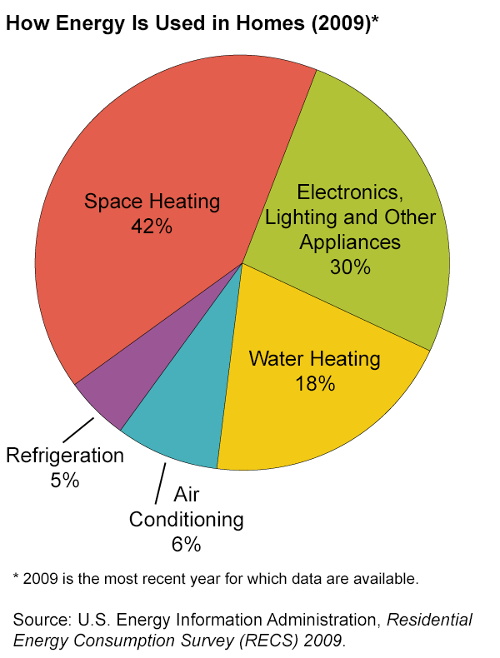

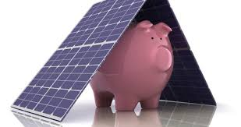
(http://www.nalsunenergy.com/how-can-you-save-money-with-solar-energy/)

Task 6 – Writing skills
Write an essay giving your opinion on the following statement:
Technological inventions have made our living more convenient.

How far do you agree or disagree with this statement? Support your opinion in 120–160 words.
___________________________________________________________________
___________________________________________________________________
___________________________________________________________________
___________________________________________________________________
___________________________________________________________________
___________________________________________________________________
___________________________________________________________________
___________________________________________________________________
___________________________________________________________________
___________________________________________________________________
___________________________________________________________________
___________________________________________________________________
___________________________________________________________________
___________________________________________________________________
___________________________________________________________________
___________________________________________________________________
___________________________________________________________________
___________________________________________________________________
___________________________________________________________________
___________________________________________________________________
___________________________________________________________________
___________________________________________________________________

