ECONOMY OF SHARING
Task 1 – Reading comprehension: short answers
Read the following text below and answer in note form.
1. What does sharing mean? _____________________________________________
___________________________________________________________________
2. Where was the first idea of organised sharing invented? ______________________
___________________________________________________________________
3. What is a car-sharing service called when you travel with other people who make the same journey as you? _______________________________________________
4. How do we call a hospitality exchange of houses? ___________________________
___________________________________________________________________
5. In which country can we find a new original platform called foodsharing? _________
___________________________________________________________________
6. Beside cars, home and food what can also be shared nowadays? ______________
___________________________________________________________________
7. Where does the idea of sharing clothes and accessories come from? ____________
___________________________________________________________________
8. Where can we share a lot of things? _____________________________________
___________________________________________________________________

Let's share!
(Adapted from the article in “A Tot of English” – The Magazine for Your English, December 2013/January 2014.)
The economy of sharing is very successful all over the world. You can share everything, from your house to your food.
Sharing means dividing the use of resources or space. This is also a very important value that reminds us of the values of generosity, love and friendship. If there are moments of economic crisis in the world, people untie to help each other and feel closer! There are a lot of positive examples of the economy of sharing.
The first idea of organised sharing was invented in San Francisco for sharing cars. If you don't want to have a car in your garage, a car-sharing service allows you to book a car to use only when you need it. This is different from car-pooling, which is when you travel with other people who make the same journey as you, with just one car. In both cases, you can save energy and money and you certainly pollute the environment less.
If you love holidays but you don't like going to hotels, and you prefer to dive into typical daily life of the places that you visit, this is the way for you to travel. It is called couch-surfing, which is like a hospitality exchange of houses of people who are registered on a special website. If you want to have a holiday in a new place, you'll find someone who can offer you their sofa in the place you want to visit.
In Germany, there is new, very original web platform which is called foodsharing and it offers sharing your food. If your fridge is full of things that you can't manage to use because you are going away or you have leftovers from a dinner, rather than throwing them away, you can give them to someone else! The only rule is: “don't give food to others which you wouldn't eat yourself”. If you want to register, you can do it in a click, and then you just wait for someone to come and empty your fridge.
Beside all these possibilities mentioned above, you can also share your clothes. Not only with your brothers and sisters but you can also exchange clothes and accessories with other people. You just need to organize a meeting online or at your home and follow the philosophy of swapping! This way you can have a wardrobe makeover without spending any money. This idea comes from Manhattan and it has become popular all over the world, and its aim is to recycle clothes, which no longer fit or are out of fashion.
A lot of things can be shared online. Facebook is a very famous example, but Dropbox is even more useful because it's like a type of big box online where you can put music, photos and files and you can share them with who you want!

Task 2 – Vocabulary exercise
Match the words in bold (Task 1) to their definitions:
1. things that remain uneaten from a meal: ____________________
2. jump into: ____________________
3. swap: ____________________
4. bags, belts and jewellery for example: ____________________
5. online programme: ____________________

Task 3 – Listening and speaking skills
Watch the video clip and express your opinion about clothes-sharing app:
interview with Robin Balser, student entrepreneur
https://www.youtube.com/watch?v=2D7iQ_fnMD8

Task 4 – Speaking: comparing pictures

Compare and contrast the following pictures:

(Source: https://www.google.com/search?q=sharing+things+pictures&rlz)

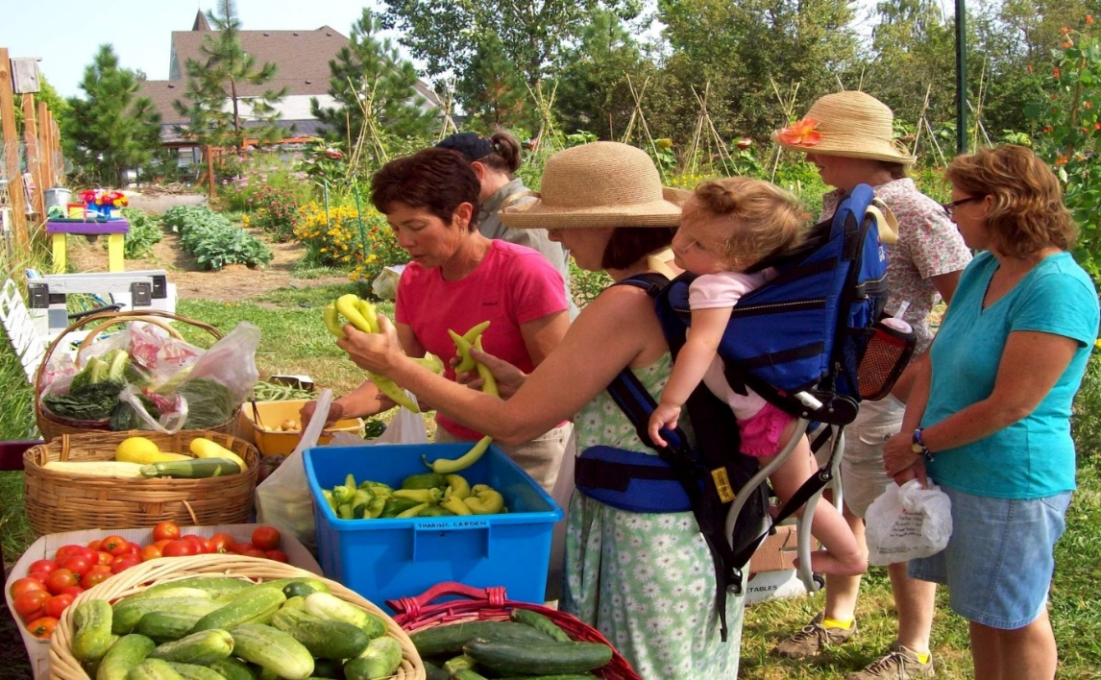

(Source: https://thesharinggardens.blogspot.com/2012/09/real-people-doing-real-things.html)

Task 5 – Writing skills

Imagine you are joining HomeExchange.com. Write a profile for the website (150–200 words). Include information about:
- you (your name, where you live, your personality, your interests),
- your home,
- your neighbourhood,
- your ideal holiday with HomeExchange (where you would like to go and why).

___________________________________________________________________
___________________________________________________________________
___________________________________________________________________
___________________________________________________________________
___________________________________________________________________
___________________________________________________________________
___________________________________________________________________
___________________________________________________________________
___________________________________________________________________
___________________________________________________________________
___________________________________________________________________
___________________________________________________________________
___________________________________________________________________
___________________________________________________________________
___________________________________________________________________
___________________________________________________________________
___________________________________________________________________
___________________________________________________________________
___________________________________________________________________
___________________________________________________________________
___________________________________________________________________
___________________________________________________________________
___________________________________________________________________

