CLOTHES AND FASHION
Task 1 – Reading comprehension

Read the text and complete the sentences with the words from the box:

fashionable glamour magazines styles shopping icon

conscious affluent contagious accessories pointless

trendy spread models limelight upgrades trendsetters

The Effect of Fashion on Teenagers in School

(Adapted from the article by Vivek Ranjanin, SelfGrowth.com, 15 September 2018.)
There was a time when the concept of fashion was only in the occasions. Though, it would be [1] ________________ to compare the present generation with our generation. But I can see a vast difference between the present and the older generation. Fashion is the key word for today’s teenagers. In fact, fashion reflects even in the school students. The bags they carry, the watches they wear and the way they carry themselves involve so much of fashion. The teenagers seem to be more [2] ________________ than the adults now. In fact, they can be good [3] ________________ themselves. There are many teens that invent their own styles and aim at becoming an [4] ________________ among their groups.
Earlier, fashion used to be found only among the [5] ________________ class of people. But now the times have changed. Now, class doesn’t matter in any way on the road to becoming fashionable. In fact, everybody is fashionable these days. We can hardly see anyone on the streets who isn’t fashion [6] ________________. One of the many factors responsible for the [7] ________________ and the craze of fashion among people so much is Television. Fashion or “style” in the colloquial language can be called [8] ________________ because people get influenced by one who already is fashion conscious. Being fashion conscious not only makes you popular among your folks but also [9]________________ your confidence level.
Teenagers of the present times have involved themselves so much with fashion that they don’t get sufficient time for other work. Instead of reading textbooks, they prefer to read fashion [10] ________________. They try hard to imitate the [11] ________________ or glam faces so as to resemblance them. The time they should spend in their studies, they spend in watching programmes on TV, reading fashion articles or finding the recent [12] ________________ clothes on the web. Unlike earlier, now the teenagers do not go out with their parents on weekends, rather they plan their outings with their friends. The prime zones for outings have now become malls for most of them because they can do a lot of [13] ________________ there apart from having fun.
Earlier children used to dream of becoming scientists, doctors or engineers or even teachers, but the priority and taste of the children of these days have changed. Most of them desire to be into the [14] ________________ world. They find the fashion world better than any other job. In fact, one who is not fashion conscious these days doesn’t get much importance. One who looks trendy in the first appearance takes away all the [15] ________________.
But it is the duty and responsibility of the parents to keep a watch over their children of whether they are using much of their time in grooming themselves or in their studies. Too much of information regarding recent trends and [16] ________________ block the minds of the children and distract them from their studies. Schools also should make some strict rules to avoid using fashionable [17] ________________ within the school premises. It’s good to keep yourself updated with fashion but if interferes in your academic performance and your time, it should be avoided.
Task 2 – Answer the questions.
- Do you agree with the author of the article that schools should make some strict rules to avoid using fashionable accessories within the school premises? _______
__________________________________________________________________________________________________________________________________
- Do you think there should be any rules regarding clothes and makeup in Slovenian schools? _________________________________________________________
_________________________________________________________________
_________________________________________________________________
- Are you for or against wearing school uniforms? __________________________
_________________________________________________________________
_________________________________________________________________
- What influence does fashion have on young people in Slovenia? _____________
_________________________________________________________________
_________________________________________________________________
- What do you think of fashionable clothes? Is fashion important to you? ________
_________________________________________________________________
_________________________________________________________________
- What do you wear for different occasions? _______________________________
__________________________________________________________________________________________________________________________________
- Some people are obsessed with fashion. Do you agree? ____________________
_________________________________________________________________
_________________________________________________________________
- Do you think beauty is important for asserting oneself in life and being successful? _______________________________________________________
_________________________________________________________________
_________________________________________________________________

Task 3 – Speaking: clothes
Which items of clothes and footwear do you see in the pictures?
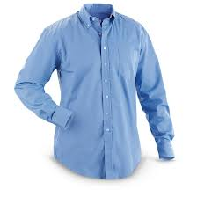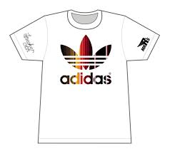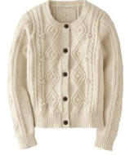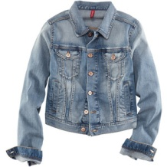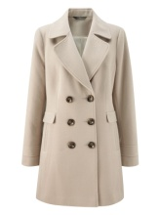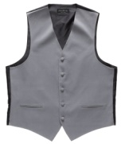
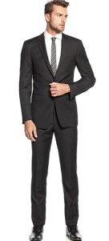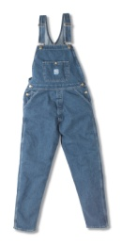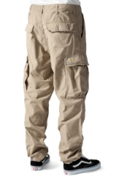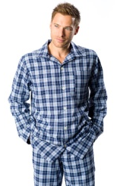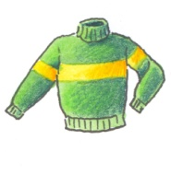
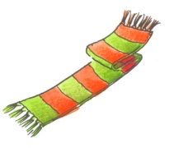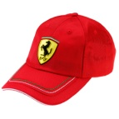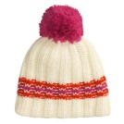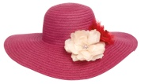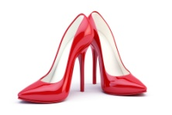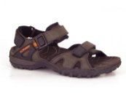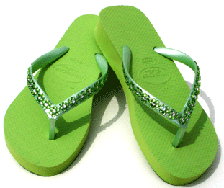
(Sources: https://www.collegefashion.net, https://learnenglishkids.britishcouncil.org, https://www.teachingenglish)

Task 4 – Vocabulary: fabric and patterns
Match the words with their definitions.
1.___ | cotton | a closely woven fabric that has a thick short pile on one side
2.___ | wool | marked or decorated with spots
3.___ | silk | having stripes or bands
4.___ | nylon | a soft white fibrous substance which surrounds the seeds of a plant and is made into textile fibre and thread for sewing
5.___ | leather | a pattern consisting of an array of large filled circles of same size
6.___ | spotted | the fine, soft curly or wavy hair forming the coat of a sheep, goat, or similar animal, especially when shorn and prepared for use in making cloth or yarn
7.___ | striped | having a pattern of small squares
8.___ | checked | a tough, lightweight, elastic synthetic fibre
9.___ | polka dots | a material made from the skin of an animal
10.___ | velvet | thread or fabric made from the fibre produced by the silkworm
Task 5 – Complete the text with the correct forms of the verbs in brackets.
Teenage Fashion History
(Adapted from the article by Bill Osgerby, LoveToKnow, 24 October 2018.)
A history of fashion is a history of humans, encompassing cultural, political and technological changes across the world. Fashion [1] ___________________ (influence) by many different factors throughout history. Early fashions developed out of necessity, with people creating apparel appropriate for their climate from the most readily available materials. As time went by, clothing [2] ______________________ (evolve) from being much more than a basic necessity; fashion began to define culture, socioeconomic conditions and status, individual expression and visual appeal.
Since World War II, clothing styles adopted by young people [3] _______________ (be) a powerful influence on the development of fashion in North America and Europe. The postwar growth of young people's spending power [4] _________________ (ensure) that the youth market became a crucial sector of the fashion business. The styles adopted by young people, moreover, also became an important influence on wider fashion trends. Indeed, by the 1990s the "youth" market [5] ____________________ (expand) to embrace not only teenagers, but also consumers in their twenties, thirties, and older.
The growth of the mass media [6] ____________________ (be) a crucial factor in the dissemination of teenage fashion. The proliferation of teen magazines, films, and TV music shows such as American Bandstand (syndicated on the ABC network from 1957), ensured that shifts in teen styles [7] ______________________ (spread) quickly throughout the United States. The global circulation of U.S. media also allowed the fashions of teenage America to spread worldwide.
During the 1980s and 1990s, a rise in youth unemployment, coupled with the declining size of the Western youth population, threatened to undermine the growth of teen spending. By the beginning of the twenty-first century, however, demographic shifts and economic trends indicated that youth [8] ___________________ (continue) to be a lucrative commercial market. Despite a long-term decline in Western birth rates, the youth population was set to increase during the new millennium as the "echo" of the "baby boom" worked its way through the demographic profiles of America and Europe. Moreover, on both sides of the Atlantic the market research indicated that teenagers' spending power [9] ________________________ (still, grow).
Teenagers [10] _______________________ (always, seek) to express themselves through fashion, often pushing the boundaries toward dress reform to change norms and leading to attacks on fashion. Teenage fashion also increasingly appealed to other age groups. By the end of the 1990s, many consumers aged from their twenties to their forties and above were favoring tastes and lifestyles associated with youth culture. Therefore, "teenage fashion” is no longer the preserve of teenagers, but [11] ___________________ (win) a much broader cultural appeal.

Task 6 – Speaking skills
How have clothes changed through history?
Compare and contrast the following photos:
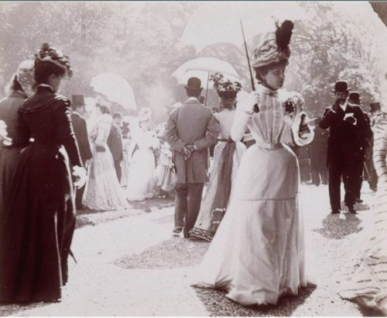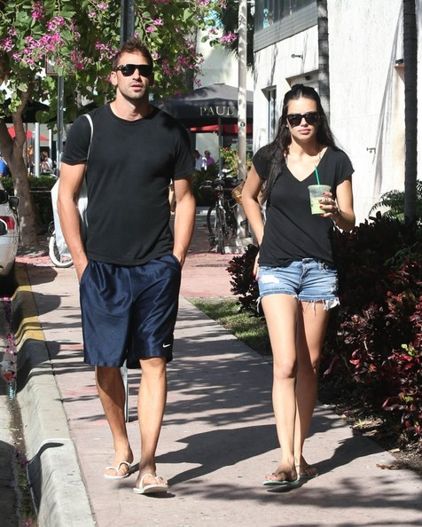
(https://stylesmatters.wordpress.com/fashion-1900-1920/) (http://www.zimbio.com/photos)

Task 7 – Listening comprehension
Listen to the following fashion tips for teenagers and write down a list of 10 fashion items which are presented in the video clip and at least one reason why would that item make the most out of your back to school season.
https://www.youtube.com/watch?v=za5n5zZcC1w
(YouTube: 10 Fashion Items That Will Make You Stand Out For Back To School by TheTalko)

Task 8 – Writing skills
Write an essay giving your opinion on the following statement:
We usually judge people by their physical appearance
and not by their inner beauty.

How far do you agree or disagree with the statement? Support your opinion in 180–220 words.

WE USUALLY JUDGE PEOPLE BY THEIR PHYSICAL APPEARANCE AND NOT BY THEIR INNER BEAUTY
___________________________________________________________________
___________________________________________________________________
___________________________________________________________________
___________________________________________________________________
___________________________________________________________________
___________________________________________________________________
___________________________________________________________________
___________________________________________________________________
___________________________________________________________________
___________________________________________________________________
___________________________________________________________________
___________________________________________________________________
___________________________________________________________________
___________________________________________________________________
___________________________________________________________________
___________________________________________________________________
___________________________________________________________________
___________________________________________________________________
___________________________________________________________________
___________________________________________________________________
___________________________________________________________________
___________________________________________________________________
___________________________________________________________________
___________________________________________________________________

