CITY LIFE VS. COUNTRY LIFE
Task 1 – Reading comprehension

Read the article and complete the gaps with the words from the box.

access advantages population experts rural facilities different
drawbacks communication settlements community

WHAT IS THE DIFFERENCE BETWEEN CITY AND COUNTRY LIFE?
(Adapted from: https://wppathfinder.com/what-is-the-difference-between-city-and-country-life/.)
People provide different opinion while choosing to live in the city or countryside. Both come up with different _________________ and _________________ as well.
Dense population, air pollution, water pollution, sound pollution and stressful life are some common scenarios in city life. Is then living in the countryside more heavenly?
A _____________ or countryside living is popularly known as village life. Basically, a village is a natural growth of a human _______________ where people live generation after generation.
Thus, the base of rural life is strong and powerful. Most of the people love living in the countryside for it's a slower pace of life and pleasant environment.
On the other hand, a city is a community of large number of ________________ that come up with lots of advantages and disadvantages as well. Most of the globalisation _______________ agree that a town gradually converts into a city to adopt huge _______________ pressure and offer all modern ________________.
Comparing with village life a city offers more advantages like job opportunities, recreational facilities, better transport, better education and all modern technologies for easy ________________. And people love city life for its fast movement.
Living in city and countryside are totally _____________. Living in countryside offers more open space, pollution-free environment, healthy food and healthy living. But most of the time people from villages depend on cities for some facilities like better education and treatment.
On the other hand, city life offers a glamorous life with all other advantages. You are in the centre of everything; you have easy _______________ to all modern amenities that make your life colourful. Although cities have all modern facilities, living there is more mechanic and complex. There are thousands of people living in a small territory and they are not inter-connected with strong bonding. Everything is most likely artificial that makes the city life stressful and complex.
Task 2 – Speaking skills
Describe and compare living in the city and living in the countryside. Use the ideas from the chart. Which one do you prefer and why? Justify your choice.
The basis for comparison | City | Country
Life | Fast and complicated | Simple
Pollution | Associated with pollution | Less pollution
Convenience | Enjoy modern exposures | Away from modern facilities
Personal Fitness | More incorporate with it | Less required
Cost of Living | Expensive | Cheap
Collective Mentality | Break down the traditional value | Put uphold their cultural heritage
Employment | Better job opportunities | More prone to blue-collar jobs
Marriage and Divorce | Drastically changing | Dominated and deeply rooted in the local culture

Task 3 – Word formation
Complete the following text with the correct form of the words in brackets.
SOCIAL VALUE AND COLLECTIVE MENTALITY
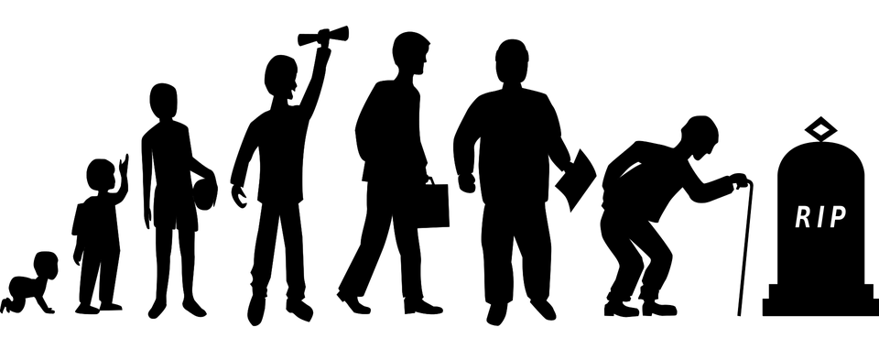Source: https://wppathfinder.com/what-is-the-difference-between-city-and-country-life/
Country life offers more ________________ (society) value and _________________ (responsible). People are ________________ (strong) connected with each other. They are also more _________________ (help) to each other and do not avoid social responsibilities. They are ________________ (respect) and _________________ (affection). ________________ (tradition) marriage system is common in the village life while in complex city life, the rate of divorce is high due to weak family _______________ (relate).

Task 4 – Speaking skills: describing a picture
Describe the picture below answering the following questions:
- Who can you see in the picture?
- What is the relationship among them?
- Where are they?
- What are they doing?
- What is your impression seeing them?

Source: https://wppathfinder.com/wp-content/uploads/2019/05/family-bonding.jpg

Task 5 – Listening comprehension
Advantages of Living in the City or the Town
Listen to the following conversation on advantages of living in the city or the town and check your comprehension with listening questions in the video clip.
https://www.youtube.com/watch?v=vzWiqrEqwqk

Task 6 – Writing skills
Write an essay giving your opinion on the following statement:
Country life is better than city life.

How far do you agree with this statement? Support your opinion in 120–180 words.
COUNTRY LIFE IS BETTER THAN CITY LIFE
___________________________________________________________________
___________________________________________________________________
___________________________________________________________________
___________________________________________________________________
___________________________________________________________________
___________________________________________________________________
___________________________________________________________________
___________________________________________________________________
___________________________________________________________________
___________________________________________________________________
___________________________________________________________________
___________________________________________________________________
___________________________________________________________________
___________________________________________________________________
___________________________________________________________________
___________________________________________________________________
___________________________________________________________________
___________________________________________________________________
___________________________________________________________________
___________________________________________________________________
___________________________________________________________________
___________________________________________________________________
___________________________________________________________________
___________________________________________________________________
___________________________________________________________________
___________________________________________________________________

