ADDICTIONS
Task 1 – Reading comprehension
Read the text and choose the best answers according to the text. Give reasons for your answers.
1. Addiction is: a) a long-term condition; b) short-term condition.
2. Drug addiction is: a) mental disease; b) brain disease.
3. People addicted to drugs: a) can stop using them when they want to; b) cannot stop using them even if they want to.
4. Drug addiction: a) can be treated; b) cannot be treated.
5. Relapse requires: a) more treatment; b) less treatment.
6. A person’s risk for drug addiction is affected: a) by only one factor; b) by various factors.
7. Triggers are situations that: a) remind someone of using drugs;
b) never remind someone of using drugs.

8. It is always important that:
a) a person maintains permanent lifestyle changes to avoid drug abuse;
b) a person maintains temporary lifestyle changes to avoid drug abuse.

RECOVERY FROM DRUG ADDICTION
(Adapted from: ScienceWorld, Vol. 71 No. 7, January 12, 2015.)
Oxford Advanced Learner’s Dictionary says that addiction to drugs is condition of taking drugs habitually and being unable to stop doing so without suffering adverse effects.
Addiction is a long-term condition and avoiding relapse is an ongoing challenge, even after many years in recovery. The sooner treatment is started, the faster someone can get healthy.
Drug addiction is a brain disease because drugs change how the brain works. People who are addicted to drugs cannot stop using them, even when they really want to because their priorities change and getting drugs becomes more important than their family, their responsibilities and their life goals. Drug addiction can be treated but recovery can take a long time. It often requires treatment throughout a person’s life. Even after a period of time without using drugs, an addicted person may have a relapse, which means, start to use them again. Relapse requires more or different treatment in order for a person to stop using drugs again.

Reasons why some people become addicted to drugs while others do not
A person’s risk for drug addiction is affected by several factors:
- genetics – some genes make people more prone to become addicted;
- family and social environment – negative influences include peer pressure, physical or sexual abuse, stress, poor relations with family members or friends and of course availability of drugs;
- mental health – mental illness could place some people at a greater risk for addiction;
- age – the younger a person is when drug use begins, the greater the chance for addiction.
Recovering from drug addiction
Addicts need treatment for drug abuse. However, not everybody gets treatment. Most people who succeed in treatment commit to a lifelong process of recovery: getting more treatment when needed, living a healthy lifestyle, relying on a family and others in recovery for support.

Why does relapse happen?
Relapse happens because drugs change the wiring in a person’s brain. Once being addicted, a person is at high risk of using drugs when being »triggered«. Patients with drug addiction must learn to carefully manage their condition to avoid relapses.
What are »triggers«?
Triggers can be situations, stress, people, smells and even songs that remind someone of using drugs. These can cause the brain to release the chemical dopamine – which signals pleasure – and creates intense drug cravings. Triggers differ for each person and are often subconscious, which means that the person is not aware of what is happening. Treatment helps people learn how to handle their triggers without using drugs.
Challenges of recovery
Recovery from drug addiction means overcoming obstacles.
It is of great importance that an addict finds the right treatment for as long as it is needed. It is also very important that a person maintains permanent lifestyle changes to avoid drug abuse. A strong support system of family members and friends can help a lot. Thirdly, it is important to avoid triggers by staying away from drug users or parties with drugs or other situations that might lead to drug cravings.

Task 2 – Vocabulary
Complete the gaps with the correct form of the words in brackets!
1. A ______________ (success) treatment plan for drug addiction puts different types of support together in a way that works for each person’s particular situation.
2. When relapse happens, it is time to step back and adjust the plan, which can be ______________ (construct) from many different types of support.
3. It is known that once addicted to drugs, the brain can be _____________ (affect) for a long time, although recovery is possible.
4. The amount of brain ____________ (active) increases over the time.
5. How much a brain recovers after _____________ (addict) depends on the drug, how long it was used, a period without using drugs and the person’s genes.

Task 3 – Listening and speaking
Watch the following videoclip and express your opinion about the topic:
Why We Are All Addicts
https://www.youtube.com/watch?v=f55QO2isoKM

Task 4 – Talking points
Answer the following questions:
1. What do people usually get addicted to?
2. How can an addiction affect someone's life?
3. When/why do everyday activities become addictive?
4. In your opinion, which addiction is the most difficult to deal with?
5. What could you do to help somebody who suffers from any kind of addiction?

Task 5 – Comparing pictures
Compare and contrast the following two pictures:

(Source: https://cdn.pixabay.com/en/wine-glass-alcohol-glass-of-wine-2891894/ps://p)

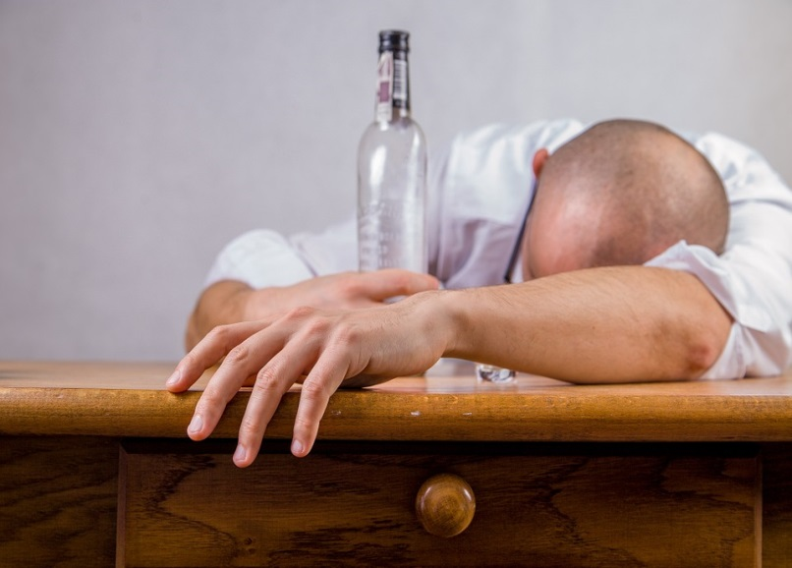
(Source: https://cdn.pixabay.com/photo/2014/08/26/20/08/alcohol-428392_960_720.jpg)

Task 6 – Writing skills
Write an essay giving your opinion on the following statement:

It is not that easy to recover from addiction.

How far do you agree with this statement? Support your opinion in 120–160 words.
___________________________________________________________________
___________________________________________________________________
___________________________________________________________________
___________________________________________________________________
___________________________________________________________________
___________________________________________________________________
___________________________________________________________________
___________________________________________________________________
___________________________________________________________________
___________________________________________________________________
___________________________________________________________________
___________________________________________________________________
___________________________________________________________________
___________________________________________________________________
___________________________________________________________________
___________________________________________________________________
___________________________________________________________________
___________________________________________________________________
___________________________________________________________________
___________________________________________________________________
___________________________________________________________________
___________________________________________________________________
___________________________________________________________________

