TRAVELLING
TASK 1 – Reading comprehension
Read the text and decide whether the statements below are true (T) or false (F):

TOP 10 BENEFITS OF TRAVELLING – LEARN WHY TRAVELLING IS GOOD

(Adapted from: https://eurama.hu/2017/02/08/benefits-of-travelling/.)

Travelling different places around the world can make our lives better and happier in several ways. We present the top benefits of travelling for everyone!
1) It teaches us about the world
“The world is a book, and those who do not travel read only a page.” – said Saint Augustine. Travelling can teach us more than any university course. We learn about the culture of the country we visit. If we talk to locals, we will likely learn about their thinking, habits, traditions and history as well.

2) It teaches us about our homeland
If we travel, we will not only learn about foreign cultures, but about our own as well. We will notice the cultural differences, and will find out what makes our culture unique. After returning from a long journey, we will see our country with new eyes.

3) It teaches us about ourselves
We can learn a lot about ourselves through travelling. We can observe how we feel being far from our country. We will find out how we feel about our homeland. We will realise how we really feel about foreign people. We will find out how much we know/do not know about the world. We will be able to observe how we react in completely new situations. We will test our language, orientation and social skills. We will not be the same persons after returning home.

4) It makes us more tolerant
During travelling, we will meet people that are very different from us. If we travel enough, we will learn to accept and appreciate these differences. Traveling makes us more open and accepting.

5) It provides us with unforgettable moments and experiences

While travelling we can experience things that we could never experience at home. We may see beautiful places and landscapes that do not exist there where we live. We usually meet many people and some of them may even change our life in the future and the way of our thinking.

6) It makes us more confident and independent
Travelling will inevitably make us more independent and confident. We learn and realise that we can cope with many unexpected situations. We will realise and experience that we can survive without all that help we usually get at home. We will likely find out in some situations that we are much stronger and braver than we have expected.

7) It lets us gain useful knowledge
We can also learn a lot of useful things. These things can be anything from the daily life like a new, more effective solution to an ordinary problem or a new way of creating something.

8) It improves our language skills
Especially when we travel to foreign countries, we can learn some new words and expressions. In this way, we can improve our knowledge of the foreign language that is spoken as a mother tongue there.

9) It motivates us
After arriving home from a journey, we may want to test new skills and knowledge gained while travelling. New experiences will give us a lot of energy.

10) It provides us with stories we can tell others
During travelling, we may experience the craziest, most exciting things that will eventually become great stories that we can tell others. When we grow old and look back at all our travel experiences, we will realise how much we have done. This can provide us with happiness and satisfaction for the rest of the life.

 | T | F
- Travelling usually makes our lives unhappier.
- Travelling can teach us more than any university course.
- If we travel, we only learn about the culture of the country we visit.
- When returning home after travelling we will not be the same persons.
- During travelling, we will meet people who are very different from us.
- Meeting new people might change our life or the way of our thinking.
- Travelling makes us more dependent.
- We cannot learn any useful things while travelling.
- While travelling we can also improve our knowledge of a foreign language.
- We can experience many interesting stories that can be later told to others.
TASK 2 – Speaking skills
Discuss the following questions about tourism in your home country:
- Do Slovenian people host/meet many foreign tourists?
- Which countries do the tourists come from?
- What do these tourists come to see and do in Slovenia?
- What are the most attractive places in Slovenia that are interesting for the tourists?
- Which cities and towns would you recommend to visit?

TASK 3 – Word formation
Complete the following article with the correct form of the words in brackets:

VENICE SIMPLON-ORIENT-EXPRESS HOLIDAYS

(Adapted from: https://www.theluxuryholidaycompany.com/destinations/europe/venice-simplon-orient-express.)

Travelling with Simplon-Orient-Express is unique, romantic, matchless experience like no other.
For decades, the Venice Simplon-Orient-Express has been synonymous with everything that is sophisticated and glamorous in the world of luxury train travel. Since its maiden journey from Paris to Istanbul in 1883, the Orient Express has been intrinsically linked with luxury travel. Now the train has been restored, refurbished and returned to its Art Deco-influenced origins. Today the enchantment and romance are as strong as ever and, in an age that prioritises speed and _____________ (efficient) when it comes to conveying you to your end destination, the experience of travelling ____________ (slow) and being on a luxury journey is even more alluring.

Made up of _____________ (origin) 1920s and 30s European carriages, lovingly restored to their original elegance and splendour. Yet the experience of being on board transcends its historical origins and feels utterly contemporary and fresh. Luxury at this level is timeless.

The train now visits a number of Europe’s most enchanting cities. Alongside the ______________ (tradition), classic journey from London to Venice via Paris (or vice versa), you can now travel to London from Vienna, Verona, Prague or Budapest. There’s an annual journey from London to Berlin as well. For the ultimate luxury rail journey it is suggested that the most discerning traveller should secure a berth on the very special, once-a-year departure from London to Istanbul, a nine-day journey that recreates the original 1883 route. The sheer romance of this experience is unmatchable.

There is no more memorable an experience than seeing the train for the first time. Arrive early at the station to get caught up in the excitement reverberating through the air. It could be at London’s Victoria station, where you board or at Calais or Venice, where you’ll get your first glimpse of the blue and gold carriages of the Continental Wagons-Lit. The thrill is palpable and these are memories that will stay with you for a lifetime.

Climb aboard and step back in time to a more refined, congenial and elegant era. Walk through all the carriages to understand that you’re travelling on a page of history, taking the time to read the plaques identifying each carriage and observing the different décor of each one.

Head to your compartment and settle in, meeting the cabin steward who will anticipate and attend your every need. Listen to a pianist play nice music in the bar and enjoy your dinner that is served by an elegant waiter. Of course, you also need to try delicious cocktail prepared by the head barman. _______________ (alternative) toast your good taste with a vintage champagne from the train’s extensive ______________ (select).

Then, settle yourself into one of the three _____________ (beautiful) restored restaurant cars, taking note of the fine linen, French silverware and heavy crystal that hint at the extravagance ahead. Perhaps you’ll try lobsters from Brittany or salt marsh lamb from Mont St Michel.
After a four-course culinary adventure, retire to your cabin, which will have been discretely converted into a sleeping compartment. Spoil yourself with a night cap then climb the upholstered ladder to your upper berth or snuggle down under luxury linens on the bottom bunk to be lulled by the _____________ (move) of the train as it travels across Europe, perhaps having taken steps to arrange a ______________ (celebrate) breakfast in the morning so that you can start the next day with another _____________ (magic) memory.

TASK 4 – Listening skills

Watch the hotel presentation on

https://www.youtube.com/watch?v=dhhCAOU_b3Y and present its

- location,
- service,
- facilities.

Would you spend your holiday there? Explain why.

TASK 5 – Writing skills:

You want to go to Greece on holiday and spend a week in the luxury hotel AEOLIS THASSOS PALACE. Send an enquiry email to the reception and ask to get accommodation.

TASK 6 – Speaking skills: describing pictures
Make up a story based on the following two pictures:
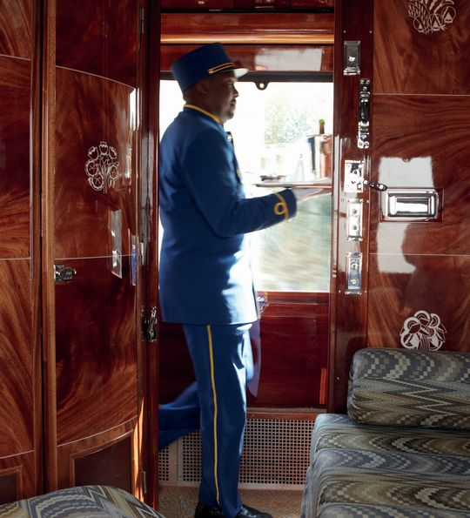
(Source: https://www.theluxuryholidaycompany.com/destinations/europe/venice-simplon-orient-express)

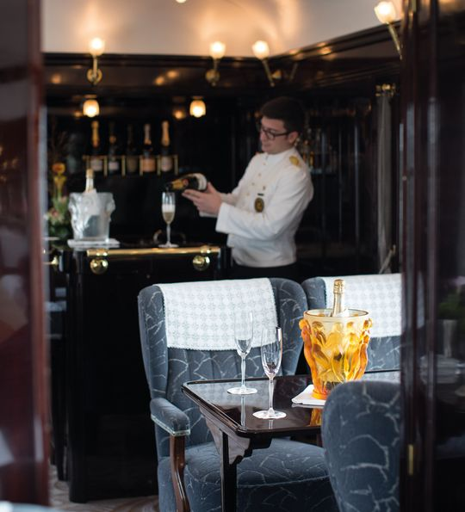
(Source: https://www.theluxuryholidaycompany.com/destinations/europe/venice-simplon-orient-express)

