MEDIA
Task 1 – Reading comprehension
Read the texts and match the people to questions 1–8. Write N for Nigel, B for Barbara, J for John, P for Paul and S for Susan.
It's often claimed that without good journalism, we wouldn't have an informed public. But the question arises as to what makes good journalism today, when the public is increasingly “informed” through more immediate, visual media, such as the Internet, satellite and cable twenty-four-hour news channels. We asked several people of different ages to tell us what their attitude towards journalism and journalists is. Here is what they had to say.
Nigel (46)
Recent events have put journalism in the spotlight and there are lessons to be learned from this. It's obvious that journalists have not been doing a very good job of educating the public about what they do and why they do it the way they do. We spend too much time talking amongst ourselves. Just assuming that our motives and methodology will be generally understood and appreciated.

Barbara (20)
I think there are bad journalists, just like there are bad hair stylists and bad architects and bad funeral directors; but the overwhelming majority of journalists are out to do a good job because they believe that what they are doing is important – getting good information, reporting accurately and fairly, telling the truth. Of course, journalists make mistakes like any other professionals whose jobs entail making dozens of judgement calls and decisions every day. But the key thing is that good journalists acknowledge their mistakes and correct them.

John (17)
Last year at school I learned that journalism was the key to understanding the media and it should always show the facts in an unbiased way. I think now, with the commercialisation of television media, most journalism has been reduced to the standard of the tabloids. And journalists? You should consider a profession that you will not need to apologise for being a member of.

Paul (23)
Most of us tend to be highly critical of journalism today, especially given that the past couple of years have not been a good time for journalism ethics. There have been far too many examples of flawed reporting and bad judgement. That's all true, but we must remember one simple fact: people are always anxious to seek out the media when doing so works to their advantage, but quick to find fault when the press covers something they don't want to talk about.

Susan (35)
It's really easy to say what makes a good journalist. But there are grey areas when it comes to what is a journalistic situation. For example, talk show hosts of almost all kinds are not generally journalists and that is not a problem as long as they are clear about it. When some talk show hosts try to »borrow« the credentials of journalism to make their statements carry the weight earned by years of honest reporting by real journalist, I have a problem with that.

(Source: Success, Upper Intermediate Students' Book, 2007.)

1. Who says that it is really easy to say what makes a good journalist? ___
2. Who thinks that most of the people tend to be highly critical of journalism today? ___
3. Who learned last year that journalism was the key to understanding the media? ___
4. Who thinks that there are bad journalists just like there are bad hair stylists and bad architects? ___
5. Who thinks that journalists make mistakes like any other professionals? ___
6. Who believes that it is important to acknowledge your mistakes and correct them? ___
7. Who says it is obvious that journalists have not been doing a very good job of educating the public about what they do? ___
8. Who is sure that recent events have put journalism in the spotlight? ___

Task 2 – Vocabulary
Match the words on the left to the following definitions on the right.
1. reader a. a person who reads and corrects texts
2. journalist b. a person who sells newspapers
3. reporter c. they deliver newspapers to people's houses
4. correspondent d. a person who takes photos for a newspaper
5. editor e. a person who writes critiques/reviews
6. critic f. a person in charge of a newspaper and prepares it for publication, he runs the newspaper
7. photographer g. a person who reads a newspaper
8. distributor h. person who writes articles for a newspaper
9. newsagent i. a person who reports news for the media
10. proofreader j. a person who comments regularly to a paper,
esp. from abroad
11. interviewer k. a person who prepares interviews with people for
a newspaper

Task 3 – Speaking
Think of some examples of media in Slovenia. Which are the most popular at the moment? Do you read/watch them yourself? And which are your favourites?
tabloid newspapers

serious newspapers

fashion magazines

game shows

television commercials

soap operas

violent crime series

television documentaries

weather forecast

real life dramas

cartoons

Task 4 – Comparing pictures
Compare and contrast the following two pictures orally:
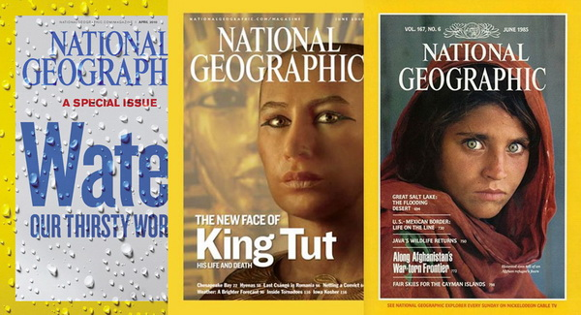
(Source: https://www.google.com/search?q=casopisi&rlz=1C2SKPL_enSI453SI462&source=lnms&tbm=isch&sa=X&ved=0ahUKEwihmdiNl_DeAhVKiKYKHYffCJcQ_AUIDigB&biw=1745&bih=881#imgrc=rhyprnP0sePEpM)
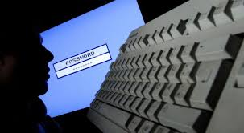
(Source: https://www.themalaysianinsight.com/resources/stories_images/19251/data_breach_oct_19_epa__full.jpg)

Task 5 – Listening and speaking
Listen to the video clip on MEDIA EFFECTS and comment on the most important guidelines you have to follow if you want to get a job you are applying for.
https://www.youtube.com/watch?v=qvgURfZMGoQ

Task 6 – Writing skills practised
Write an essay (180−200 words) giving your opinion on the following statement:
TRUSTWORTHINESS OF MASS MEDIA
There has been recent debate about whether the media accurately presents information and whether people can trust media. You might focus your argument on mass media in general or one specific form of media such as cable news or newspapers.

TRUSTWORTHINESS OF MASS MEDIA
___________________________________________________________________
___________________________________________________________________
___________________________________________________________________
___________________________________________________________________
___________________________________________________________________
___________________________________________________________________
___________________________________________________________________
___________________________________________________________________
___________________________________________________________________
___________________________________________________________________
___________________________________________________________________
___________________________________________________________________
___________________________________________________________________
___________________________________________________________________
___________________________________________________________________
___________________________________________________________________
___________________________________________________________________
___________________________________________________________________
___________________________________________________________________
___________________________________________________________________
___________________________________________________________________
___________________________________________________________________
___________________________________________________________________
___________________________________________________________________
___________________________________________________________________
___________________________________________________________________
___________________________________________________________________
___________________________________________________________________
___________________________________________________________________
___________________________________________________________________
___________________________________________________________________
___________________________________________________________________
___________________________________________________________________

