LIFE IN THE FUTURE
Task 1 – Gapped sentences
In the following extract, seven sentence parts have been removed. Choose from the sentence parts A–H the one that fits each gap (1–7). There is one extra sentence part that you do not need to use.
- who need personal aides
- to produce live answers in real-time
- "Sophia is an evolving genius machine,"
- Sophia once said it would "destroy humans,"
- lifelike robots are the future
- when it comes to smooth conversation
- "She has also become a media darling,"
- they'd talk to a friend

Meet the first-ever robot citizen – a humanoid named Sophia
(Adapted from the article in Business Insider, 29 October 2017, by Chris Weller.)
Sophia the robot might not have a heart or brain, but it does have Saudi Arabian citizenship. As of October 25, Sophia is the first robot in history to be a full citizen of a country. Sophia was developed by Hanson Robotics, led by AI developer David Hanson. It spoke at this year's Future Investment Initiative, held in the Saudi Arabian capital of Riyadh.

(1. ___) the company states on its website. "Over time, her increasing intelligence and remarkable story will enchant the world and connect with people regardless of age, gender, and culture."

David Hanson, a former Disney Imagineer, created the robot with the goal of helping the elderly (2. ___) and the general public at major events or parks. "Our quest through robots like Sophia is to build the full human experience into the robots, make robots that can really understand us and care about us," Hanson told Business Insider in January. He wants people to interact with Sophia in the same way (3. ___). Eventually, he hopes the robot can perceive the social world just as it perceives the physical world. Its current state is still a bit rough (4. ___).

Sophia has a flesh-colored zipper running down the base of its neck, and the exposed plastic skull doesn't quite sell the illusion of humanity. But the guts of Sophia's machinery are intriguing. Along with the mechanical systems that give Sophia the ability to "emote," the machine learning software stores bits of conversation in its memory and tries to grasp the flow of discussion (5. ___).

"Sophia is Hanson Robotics' latest and most advanced robot," the website states.
Ultimately, Hanson wants to mimic humans' capacity for love, empathy, anger, jealousy, and the sense of being alive.

His goal is to help provide answers to the questions: What is life? What is intelligence? What is consciousness?

His mission is to get people accustomed to seeing Sophia's face and have them gain an appreciation for the advances AI has made. (6. ___) the Hanson Robotics website explains, "having given numerous interviews to multiple media outlets, sang in a concert, and even graced the cover of one of the top fashion magazines."
Soon, Hanson will unveil other robots to join Sophia in a humanoid family, and perhaps eventually a society.

Among its fleet of robots, the product Hanson Robotics champions the most for consumer use is the Professor Einstein robot. The 14-inch-tall personal assistant was designed to make over 50 facial expressions as users ask about the weather, traffic, and basic trivia. Jeanne Lim, chief of marketing for Hanson Robotics, told Business Insider in January that the company believes (7. ___).
Hanson himself, however, believes that future is much more immediate. "The age of living androids is among us," he told Business Insider.

Task 2 – Match the words in bold to their definitions:
- the ability or power to do or understand something =
- a person who purchases goods and services for personal use =
- a bone framework enclosing the brain =
- adapted to existing conditions =
- seize and hold firmly =
- become aware or conscious of something =
- facts about people, events, etc. that are not well-known =
- to show or reveal something =
- having human form or characteristics =
- a robot that looks like a person =
- fill someone with great delight; charm =
- consisting of, including, or involving more than one =
Task 3 – Listening and speaking
Listen to the following video clip and express your opinion about a robot receiving full citizenship:
Interview With The Lifelike Hot Robot Named Sophia:
https://www.youtube.com/watch?v=S5t6K9iwcdw

Task 4 – Speaking: comparing pictures
Compare and contrast the following pictures:
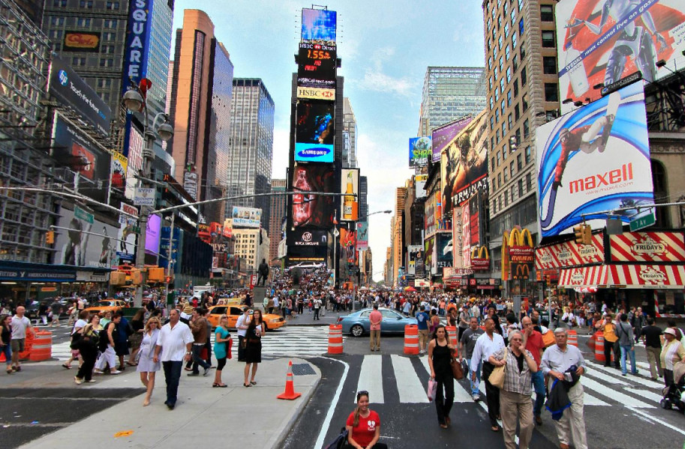
(https://imgs.6sqft.com/wp-content/uploads/2015/08/20150605/times-square)
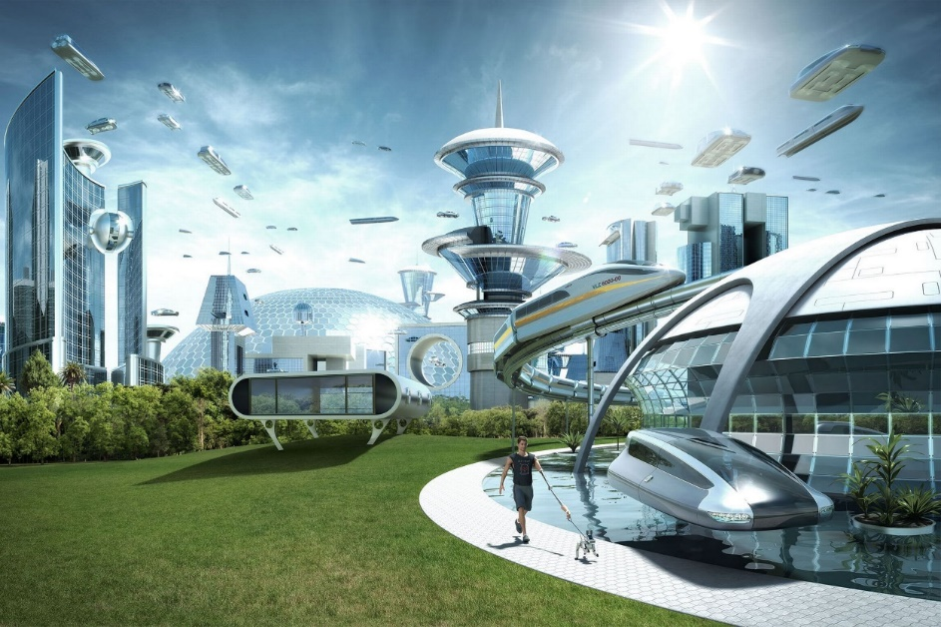
(https://www.pinterest.com/What-a-city-of-the-future-might-look-like)
Task 5 – Talking points
Answer the following questions:
  - Which inventions do you expect in the future?
  - In your opinion, will life in the future be easier or harder for people? Will people be happier?
  - What would an ideal society be like? What's your opinion?
  - How do you think the children will be educated in the future? Will they still have to go to school?
  - What is your opinion about fortune-tellers? Can you believe their predictions?
  - Where can you see yourself 10 years from now?
Task 6 – Writing skills
Write an essay giving your opinion on the following statement:
Artificial intelligence is not dangerous to humanity.
How far do you agree or disagree with the statement? Support your opinion in 120– 160 words.
ARTIFICIAL INTELLIGENCE IS NOT DANGEROUS TO HUMANITY
___________________________________________________________________
___________________________________________________________________
___________________________________________________________________
___________________________________________________________________
___________________________________________________________________
___________________________________________________________________
___________________________________________________________________
___________________________________________________________________
___________________________________________________________________
___________________________________________________________________
___________________________________________________________________
___________________________________________________________________
___________________________________________________________________
___________________________________________________________________
___________________________________________________________________
___________________________________________________________________
___________________________________________________________________
___________________________________________________________________
___________________________________________________________________
___________________________________________________________________
___________________________________________________________________
___________________________________________________________________

