FOOD AND EATING HABITS
Task 1 – Gapped headings
In the following text, 10 headings have been removed. Choose from 1–9 the one which fits best.

1 – Rationing
2 – Eating on the go
3 –TV dinners
4 – Variety
5 – Traditional food
6 – Unhealthy food
7 – Family life
8 – Convenience
9 – A better diet

Eating Habits

(Adapted from the article in CLUB Magazine, September/October 2012.)

Eating habits have changed a lot in the last sixty years. The following short texts show us how people ate in the 1950s – and then compare it to the present day …

1950s

______________________

For many years after the Second World War (1939–1945), families in the UK were limited in what they could eat – because the war made it difficult to produce and trade food. For example, during the war, a family could only buy one egg a week! Tea was rationed until 1952, sweets until 1953 and meat and cheese until 1954.
______________________
Family life was very different in the 1950s. People got married at a younger age. The man went to work while the woman was expected to be a housewife, so she had time to prepare and cook meals. Families would eat together around the dinner table.
______________________
Bread, milk, vegetables and cake were the most common foods eaten in the 1950s, and tea was the most popular drink. However, there were also many new types of food. Fish fingers, for example, went on sale in 1955.

______________________
Believe it or not, a study has shown that teens in the 1950s had a better diet than they do now – even though they were poorer and the food they had was more limited. Although children ate more animal fat in the 1950s (like butter and meat), they also did more exercise.

NOW
______________________
After the invention of fridges, freezers and microwave oven, convenience food became more common. This meant people could buy pre-cooked food and meals and frozen food – rather than cooking at home. But this also means less fresh food is prepared now.
______________________
The British diet has become more varied. Chinese and Indian food is more popular, as well as hamburger and pizza restaurants. The UK now has a multicultural population – and because of this, there are more foods to choose from, such as Vietnamese, Japanese Italian and Greek.
______________________
Crisps, chips, sweets, fizzy drinks and fast food. These things weren't at all common in the 1950s – but they are everyday foods now. Today only 1 in 5 children had five or more portions of fruit or vegetables a day – and Brits eat over 150,000 McDonald's burgers a day!
______________________
People are more likely to eat a snack while moving between two places, or eat something while standing up or on public transport, such as the bus or train. Eating is less of a special occasion and often something to fit around a busy schedule.
______________________
One study has found that 42 % of teens eat their dinners while watching TV! The study showed that kids who eat dinner with their families at a table eat more vegetables and drink more water and fewer fizzy drinks than those who don't. Eating while watching TV is more likely to lead to snacking and weight problems.

Task 2 – Vocabulary exercise
Match the words in bold and italic writing from Task 1 with their definitions:
a) involving people from many different countries, races or religions: ______________
b) food that can be prepared quickly and easily: ______________
c) when the amount of food that people eat is limited by the government: ______________
d) a compartment in a refrigerator where food is stored for a longer period at a temperature below freezing point: ______________
e) having a lot of bubbles of gas; carbonated: ______________
f) eating snacks between or instead of main meals: ______________

Task 3 – Writing skills
Interview a grandparent or an older relative of yours and find out more about food in the 1950s.
Try to find the answers to the following questions:
- What were the 1950s like in Slovenia?
- What did people eat?
- How did they live?
Write an interview in 120–150 words.
___________________________________________________________________
___________________________________________________________________
___________________________________________________________________
___________________________________________________________________
___________________________________________________________________
___________________________________________________________________
___________________________________________________________________
___________________________________________________________________
___________________________________________________________________
___________________________________________________________________
___________________________________________________________________
___________________________________________________________________
___________________________________________________________________
___________________________________________________________________
___________________________________________________________________
___________________________________________________________________
___________________________________________________________________
___________________________________________________________________
___________________________________________________________________
___________________________________________________________________
___________________________________________________________________
___________________________________________________________________
___________________________________________________________________
___________________________________________________________________
___________________________________________________________________
___________________________________________________________________
___________________________________________________________________
___________________________________________________________________
___________________________________________________________________
___________________________________________________________________
___________________________________________________________________

Task 4 – Listening and speaking skills
Watch the video clip from »Balanced Diet« on Food Groups and comment on the most important five food groups if you want to have a balanced diet.
https://www.youtube.com/watch?v=8zt-KYP_4vg

Task 5 – Speaking: comparing pictures
Compare and contrast the following two pictures:
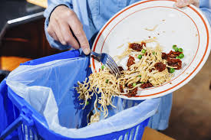
(Source: https://us.toluna.com/opinions/4223760/Do-you-waste-food)

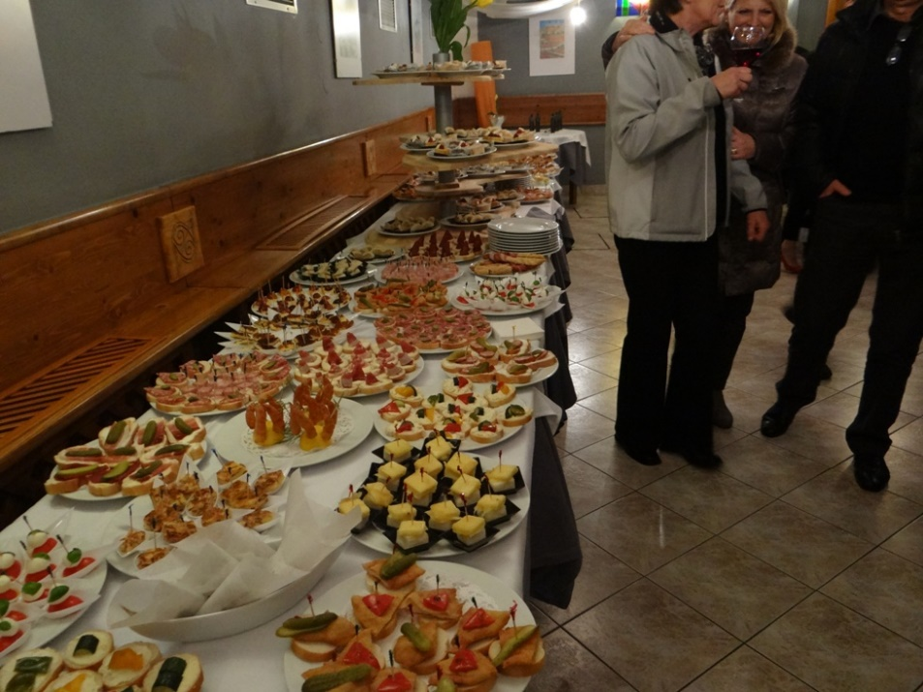
(Source: https://sdbreginjskikot.files.wordpress.com/2013/03/sprejem-jubilantov-pri-c5beupanji-pogostitev.jpg?w=468)

