FESTIVALS AND CELEBRATIONS
TASK 1 – Reading comprehension
Read the following text about the Glastonbury festival and answer the questions below in note form.
THE UK'S MOST FAMOUS MUSIC AND PERFORMING ARTS FESTIVAL
(Adapted from: https://www.festicket.com/festivals/glastonbury-festival/2019/, https://www.efestivals.co.uk/festivals/glastonbury/.)
Glastonbury Festival is the UK's most famous music and performing arts festival and one of the world's most famous festivals. Embracing each genre across the spectrum, from rock and pop, to minimal house, techno and full-throttle drum 'n' bass, music-lovers flock to its spiritual fields down in Somerset. It is simply a fantastic event.

It has been run by Somerset farmer Michael Eavis at Worthy Farm, near Glastonbury in Somerset since 1970 and he still continues to run it with massive enthusiasm.

Famed for its huge headline sets on its hallowed Pyramid Stage, which has recently played host to the Arctic Monkeys, Rolling Stones, Kanye West and Radiohead, it's the other side of the festival that really sets the heart racing. Take a stroll through Shangri-La – the festival's night time district – and you'll be thrown into a themed world full of immersive theatre, pranks and tricks, sound tracked by electronic music's finest and underground names.

The festival normally takes place on the last full weekend of June, and is known to take a year off now and then to give both the land (a working farm) and the locals a chance to recover.
After problems with excessive numbers in 2000, many improvements in security and general organisation were made, and many of the problems associated with the festival either reduced or eliminated completely. Since then the local Council have hailed the event a great success, and the future of the festival has been assured.
- Where does the UK's most famous music festival take place? _____________ ______________________________________________________________
- What genres are presented there? __________________________________ ______________________________________________________________
- Who has run the festival? _________________________________________
- Since when has it been organised? __________________________________
- When does the festival usually take place? ____________________________
- Does it happen regularly every year? ________________________________
- There were some problems in 2000. What has been done since then? ______________________________________________________________
TASK 2 – Speaking skills
Compare the following two pictures and describe them.
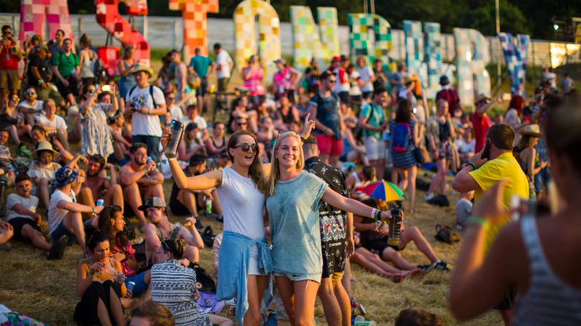
Source: https://i2-prod.somersetlive.co.uk/whats-on/article128578.ece/ALTERNATES/s1200/SWNS_GLASTONBURY_SUNSET_6.jpg
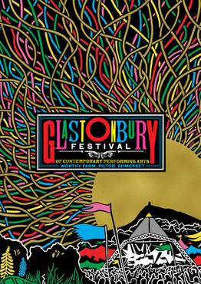
Source: https://www.festicket.com/festivals/glastonbury-festival/2019/

TASK 3 – Word formation
Complete the following article with the correct form of the words in brackets.
GET READY TO EXPERIENCE COUNTRY
(Adapted from: https://tatankamusicfest.com/the-festival/.)
Tatanka Ranch is Oklahoma's getaway destination. It's nestled on 1,000 acres just outside of Stroud, Oklahoma. Tatanka is a premium event venue for adventure __________________ (seek) and concert-________________ (go) alike.
All ________________ (active) taking place for the Tatanka Music festival can be enjoyed within the sprawling grounds of Tatanka Ranch. Come and embrace the spirit of Oklahoma in this ________________ (amaze) one-day festival!

concert goer's guide

___________________ (remind) and __________________ (recommend) to ensure you have the best experience
Whether you’ve attended an event with us before, or it’s your first time at the ranch, we have some advice to help you have the best experience at Tatanka Music Fest!
- Arrive at least an hour before the music starts to _______________ (sure) you have time to park, pass through ________________ (secure) and familiarize yourself with the festival grounds.
- Drink lots of water, and make sure to apply sunscreen! Oklahoma summers are no joke.
- 21 and up? Make sure to show your ID and get a wristband when you arrive so you can enjoy our beer garden or an adult beverage from one of our vendors.
For information on ticketing, parking, ________________ (permit) and ________________ (prohibit) items, and other activities available during the festival, please read our FAQs.

RULES & REGULATIONS

Our top _______________ (prior) at Tatanka Ranch is the ______________ (safe) and comfort of our guests.
We’re committed to creating an ________________ (enjoy) experience for our guests, and as our guest, your behaviour determines the experience for yourself and for others around you.
We ask that all guests abide Tatanka Ranch rules, be aware of the __________________ (behave) and respect other guests.
TASK 4 – Dictionary work
Look up the words in bold type in the English-English dictionary and make a meaningful sentence with each of them.
THE FOLLOWING ACTIONS WILL GET YOU BOOTED FROM THE RANCH:
- Irresponsible alcohol use or consumption.
- Public nudity or obscene clothing.
- Accessing seated/restricted areas without proper passes.
- Taunting, abusive, or disruptive language and obscene or offensive gestures, imagery or symbolism.
- Possession/use/sale of illegal drugs.
- Urinating in public (anywhere other than a proper restroom).
- Fighting or engaging in any action that may harm, endanger, threaten or bring discomfort to anyone.
- Engaging in sexual behaviour in public.
- Damage, destruction, vandalism or theft of any property.
- Any attempt to interact, abuse or disrupt the buffalo on the grounds.
Any individual participating in any of these behaviours will be immediately removed from the venue, access to the venue will be revoked, and no refund will be issued.
___________________________________________________________________
___________________________________________________________________
___________________________________________________________________
___________________________________________________________________
___________________________________________________________________
___________________________________________________________________
___________________________________________________________________
___________________________________________________________________
___________________________________________________________________
___________________________________________________________________
___________________________________________________________________
___________________________________________________________________
___________________________________________________________________
___________________________________________________________________
___________________________________________________________________
___________________________________________________________________
___________________________________________________________________
___________________________________________________________________
___________________________________________________________________
___________________________________________________________________
TASK 5 – Listening skills
Watch and listen to the video clip Best Festivals in the World – 10 Unusual Celebrations and National Customs and write down the key information about them and present them orally.
https://www.youtube.com/watch?v=9l3WiwugNFE
Notes:

TASK 6 – Vocabulary
BEST FESTIVALS IN THE WORLD: 10 UNUSUAL CELEBRATIONS AND NATIONAL CUSTOMS
(Adapted from: https://dev.invidio.us/watch?v=9l3WiwugNFE.)
Read the text and fill in the gaps with the words given in the box below.
activities creation theme popular customs traditions

National customs and ______________, as well as various tourism ______________ have led to the ______________ and popularization of various festivals, which attract thousands of people from different parts of the globe.

These days we may see ____________ festivals dedicated to honourable event in country’s history or to art, competitions or modern music.

Tastes differ and some celebrations are more ______________ than the others but we have tried to put together a top 10 list of the most interesting, unusual and exiting celebrations and ______________ every tourists should try out:
- Pingxi Lantern Festival, Taiwan,
- The Albuquerque Balloon Festival, USA,
- Bastille Day, France,
- Burning Man, Black Rock desert, USA,
- Holi (international),
- Oktoberfest, Munich, Germany,
- Snow and ice festival, Harbin, China,
- Mardi Gras, New Orleans,
- San Fermin, Pamplona, Spain,
- Carnival in Venice, Italy.

TASK 7 – Writing skills
Write an essay on the importance of celebrations and festivals in our lives in 188–200 words.
THE IMPORTANCE OF CELEBRATIONS AND FESTIVALS IN OUR LIVES
___________________________________________________________________
___________________________________________________________________
___________________________________________________________________
___________________________________________________________________
___________________________________________________________________
___________________________________________________________________
___________________________________________________________________
___________________________________________________________________
___________________________________________________________________
___________________________________________________________________
___________________________________________________________________
___________________________________________________________________
___________________________________________________________________
___________________________________________________________________
___________________________________________________________________
___________________________________________________________________
___________________________________________________________________
___________________________________________________________________
___________________________________________________________________
___________________________________________________________________
___________________________________________________________________
___________________________________________________________________
___________________________________________________________________
___________________________________________________________________
___________________________________________________________________
___________________________________________________________________
___________________________________________________________________
___________________________________________________________________
___________________________________________________________________

