CONSUMER SOCIETY
Task 1 – Reading comprehension
- Complete the following text with the missing headings. Choose from the list the one that fits best. There are two extra headings that you do not need to use.

- Economic Conditions  - Geography  - Personal Preferences  - Marketing Campaigns | - Age and Stage in the Life Cycle  - Purchasing Power  - Group Influence

5 COMMON FACTORS INFLUENCING CONSUMER BEHAVIOUR

(Adapted from: https://www.iresearchservices.com/5-common-factors-influencing-consumer-behavior.)
Consumer behaviour can be broadly classified as the decisions and actions that influence the purchasing behaviour of a consumer. What drives consumers to choose a particular product with respect to others is a question, which is often analysed and studied by marketers. Most of the selection process involved in purchasing is based on emotions and reasoning. The study of consumer behaviour not only helps to understand the past but even predicts the future. The below underlined factors pertaining to the tendencies, attitude and priorities of people must be given due importance to have a fairly good understanding of the purchasing patterns of consumers.
_____________________________
Advertisement plays a greater role in influencing the purchasing decisions made by consumers. They are even known to bring about a great shift in market shares of competitive industries by influencing the purchasing decisions of consumers. The Marketing campaigns done on regular basis can influence the consumer purchasing decision to such an extent that they may opt for one brand over another or indulge in indulgent or frivolous shopping. Marketing campaigns if undertaken at regular intervals even help to remind consumers to shop for not so exciting products such as health products or insurance policies.
_____________________________
Consumer spending decisions are known to be greatly influenced by the economic situation prevailing in the market. This holds true especially for purchases made of vehicles, houses and other household appliances. A positive economic environment is known to make consumers more confident and willing to indulge in purchases irrespective of their personal financial liabilities.
______________________________
At the personal level, consumer behaviour is influenced by various shades of likes, dislikes, priorities, morals and values. In certain dynamic industries such as fashion, food and personal care, the personal view and opinion of the consumer pertaining to style and fun can become the dominant influencing factor. Though advertisement can help in influencing these factors to some extent, the personal consumer likes and dislikes exert greater influence on the end purchase made by a consumer.
_____________________________
Group influence is also seen to affect the decisions made by a consumer. The primary influential group consisting of family members, classmates, immediate relatives and the secondary influential group consisting of neighbours and acquaintances are seen have greater influence on the purchasing decisions of a consumer. Say for instance, the mass liking for fast food over home cooked food or the craze for the SUV’s against small utility vehicle are glaring examples of the same.
______________________________
Purchasing power of a consumer plays an important role in influencing the consumer behaviour. The consumers generally analyse their purchasing capacity before making a decision to buy and products or services. The product may be excellent, but if it fails to meet the buyers purchasing ability, it will have high impact on its sales. Segmenting consumers based on their buying capacity would help in determining eligible consumers to achieve better results.
Understanding, analysing and keeping track of consumer behaviour is very critical for a marketing department to retain their position successfully in the market place. There are various other factors too that influence consumer behaviour apart from the four listed above.

- Answer the following questions.

- When you go shopping what influences you more – the price, the quality, the layout of the shop, the advertisements or some other factors? Explain why.
____________________________________________________________________________________________________________________________________________________________________________________________________________________________________________________________________
__________________________________________________________________________________________________________________________________

- Are you a shopaholic or someone who hates shopping?
_________________________________________________________________
_________________________________________________________________

- When shopping in a supermarket, are you a ‘basket-person’ – just buying a few things for the next day – or a ‘trolley-person’ – doing the weekly shop from a long shopping list? ______________________________________________________
_________________________________________________________________

- Have you ever bought anything from a catalogue or shopped online? What did you buy? How safe do you think it is to shop online? Do you worry about credit card fraud? ___________________________________________________________
___________________________________________________________________________________________________________________________________________________________________________________________________

- Would you like to work in a shop or be a market stallholder? Why/not? _________
_________________________________________________________________
_________________________________________________________________

- Do you prefer shopping in well-known chain stores or in little boutiques? _______
__________________________________________________________________________________________________________________________________

- Have you ever haggled? How successful were you? ______________________
_________________________________________________________________
_________________________________________________________________

Task 2 – Vocabulary exercise

Match the words from the box with the definitions.

corner shop browse pop round department store haggle grocery store muzak window shopping flea market

- _____________ = walk through a shop looking at things, without buying
- _____________ = walking past shop windows, looking at things, but not buying
- _____________ = argue about the price
- _____________ = quiet music played in shopping centres
- _____________ = visit somewhere near very briefly
- _____________ = a shop that sells many different items in different departments
- _____________ = a shop on the corner of your street, selling a range of basic goods
- _____________ = a group of stalls selling old furniture or clothes
- _____________ = a shop that sells food

Task 3 – Speaking skills

Describe the photo with the help of the following suggestions:

HOW TO DESCRIBE PICTURES AND PHOTOS
STEP 1: Focus on the main part of the picture at the beginning.
STEP 2: Describe the details.
STEP 3: Make assumptions with modal verbs.
STEP 4: Describe your personal experiences and examples from your life.
STEP 5: Express your opinion about the topic of the picture.

(Source: https://kidsspeak.info/managing-childrens-behavior-public)

Task 4 – Listening and speaking

Listen to the following video clip and express your opinion about the unusual shopping mall in Sweden:
THE SHOPPING MALL WHERE EVERYTHING IS RECYCLED – BBC NEWS:
https://www.youtube.com/watch?v=P-SVQTxQcrg

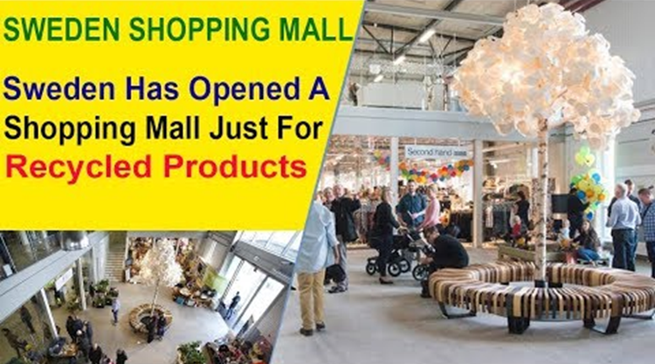
Task 5 – Writing skills

How far do you agree or disagree with the following statement?

“We always want more. Whether it is better clothes, a bigger house, faster cars, or the latest gadgets, satisfaction in these days of consumerism is difficult to find.” (Tulsi Tanti)
Write an argumentative essay about the consumer society in approximately 220–250 words.

THE BENEFITS AND DRAWBACKS OF LIVING
IN THE CONSUMER SOCIETY
(argumentative essay)
___________________________________________________________________
___________________________________________________________________
___________________________________________________________________
___________________________________________________________________
___________________________________________________________________
___________________________________________________________________
___________________________________________________________________
___________________________________________________________________
___________________________________________________________________
___________________________________________________________________
___________________________________________________________________
___________________________________________________________________
___________________________________________________________________
___________________________________________________________________
___________________________________________________________________
___________________________________________________________________
___________________________________________________________________
___________________________________________________________________
___________________________________________________________________
___________________________________________________________________
___________________________________________________________________
___________________________________________________________________
___________________________________________________________________
___________________________________________________________________
___________________________________________________________________
___________________________________________________________________
___________________________________________________________________
___________________________________________________________________
___________________________________________________________________
___________________________________________________________________
___________________________________________________________________
___________________________________________________________________
___________________________________________________________________
___________________________________________________________________
___________________________________________________________________
___________________________________________________________________
___________________________________________________________________
___________________________________________________________________
___________________________________________________________________
___________________________________________________________________
___________________________________________________________________
___________________________________________________________________
___________________________________________________________________
___________________________________________________________________

