ART

TASK 1 – Reading comprehension

Gapped sentences
In the following extract, nine sentence parts have been removed. Choose from sentence parts A–J the one that fits each gap (1–9). Write your answers in the spaces next to the numbers.

WAYS OF DEFINING ART
(Adapted from: https://www.thoughtco.com/what-is-the-definition-of-art-182707.)
There is no universal definition of visual art though (1) _____ that art is the conscious creation of something beautiful or meaningful using skill and imagination. The definition and perceived value of works of art (2) _____ and in different cultures.
The term “art” is related to the Latin word “ars” meaning art, skill, or craft. The first known use of the word comes from 13th-century manuscripts.
The definition of art has been debated (3) _____. ”What is art?” is the most basic question in the philosophy of aesthetics, which really means, “how do we determine what is defined as art?” This implies two subtexts: (4) _____. The definition of art has generally fallen into three categories: representation, expression, and form.
Throughout the centuries in Western culture from the 11th century on through the end of the 17th century, the definition of art was anything done with skill as the result of knowledge and practice. This meant that artists honed their craft, learning to replicate their subjects skilfully.
During the Romantic period of the 18th century, as a reaction to the Enlightenment and its emphasis on science, empirical evidence, and rational thought, art began to be described as not just being something done with skill, but something that was also created in the pursuit of beauty (5) _____. Nature was glorified, and spirituality and free expression (6) _____. Artists, themselves, achieved a level of notoriety and were often guests of the aristocracy.
The Avant-garde art movement began in the 1850s (7) _____. It was followed by other modern art movements such as cubism, futurism, and surrealism, in which the artist pushed (8) _____. These represented innovative approaches to art-making and the definition of what is art expanded to include the idea of the originality of vision.
The idea of originality in art persists, leading to ever more genres and manifestations of art, such as digital art, performance art, conceptual art, environmental art, electronic art, etc.
There are as many ways to define art (9) _____, and each definition is influenced by the unique perspective of that person, as well as by their own personality and character.
Sentence parts:
A – have changed throughout history
B – the essential nature of art and its social importance (or lack of it)
C – were celebrated
D – with realism of Gustave Courbet
E – as there are people in the universe
F – the boundaries of ideas and creativity
G – for centuries among philosophers
H – and to express the artist’s emotions
J – there is general consensus

TASK 2 – Speaking skills
Answer the questions below and present your attitude to visiting an art gallery:
- What do you expect when visiting an art gallery?
- How do you behave when visiting an art gallery?
- Do average people enjoy the art galleries?
- What have you learned from visiting museums and art galleries?
- Why are art galleries important?
- What should you say or do to fake it at an art gallery event if you know nothing about art?
- What is the importance of visiting art galleries?
- What are art dealers and gallery owners looking for during a studio visit, besides good art?
- What is the difference between an art gallery and museum?
- What should you see at the National Gallery of Art?
(Source: https://www.quora.com/What-should-people-know-when-visiting-an-art-gallery-for-the-first-time)
TASK 3 – Speaking skills

Compare and contrast the following two pictures:
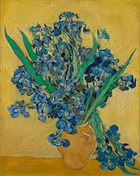
Source: https://houmuse.org/explore/events/vincent-van-gogh-his-life-in-art/

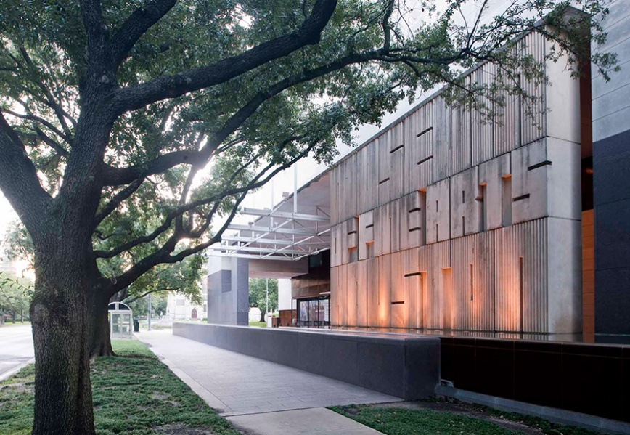
Source: https://houmuse.org/explore/events/vincent-van-gogh-his-life-in-art/

TASK 4 – Listening and speaking
Listen to the following videoclip https://www.youtube.com/watch?v=HwKfnV6zscg and answer the questions below:
- Can you do what you love and still make money?
- What career options are available to you if you want to pursue art or design?

TASK 5 – Writing skills
Write an essay giving your opinion on the following statement:
Choose ONE essay title:
- The purpose of art is washing the dust of daily life off our souls.
(Pablo Picasso)
2. Art is not what you see, but what you make others see. (Edgar Degas)
Underline the essay title you have chosen. How far do you agree or disagree with the statement? Support your opinion in 220–250 words.

_____________________________________________________________
___________________________________________________________________
___________________________________________________________________
___________________________________________________________________
___________________________________________________________________
___________________________________________________________________
___________________________________________________________________
___________________________________________________________________
___________________________________________________________________
___________________________________________________________________
___________________________________________________________________
___________________________________________________________________
___________________________________________________________________
___________________________________________________________________
___________________________________________________________________
___________________________________________________________________
___________________________________________________________________
___________________________________________________________________
___________________________________________________________________
___________________________________________________________________
___________________________________________________________________
___________________________________________________________________
___________________________________________________________________
___________________________________________________________________
___________________________________________________________________
___________________________________________________________________
___________________________________________________________________
___________________________________________________________________
___________________________________________________________________
___________________________________________________________________
___________________________________________________________________
___________________________________________________________________
___________________________________________________________________
___________________________________________________________________
___________________________________________________________________
___________________________________________________________________
___________________________________________________________________
___________________________________________________________________
___________________________________________________________________
___________________________________________________________________
___________________________________________________________________
___________________________________________________________________
___________________________________________________________________
___________________________________________________________________

