ANIMALS

TASK 1 – Reading comprehension
Read the text and complete the gaps with the words from the box:

anthropologists temperature species scales organisms habitats
blooded feather marine creature limbed popular

THE FANTASTIC WORLD OF ANIMALS
(Adapted from: http://www.animalsworlds.com/.)

The article discusses the scientific classification of different animals and their basic physical characteristics. This knowledge about the animals is a must for those who are interested in the wild life.
The beauty, courage and tenderness of animals teach us something new in our day-to-day life. Ecologists learn about the human life in the fragile web of life by studying about the animals that share our world. By studying about the animal habitat, anatomy and relatives psychologists and ____________________ learn about human development.
The website Animals Worlds acts as an information bank that can be used by students and teachers to learn about them and their habitat in the world.
Animals are multicellular __________________ that belong to the class Animalia. Animals have a fixed body plan as they develop and later in their life, they might undergo the process called Metamorphosis. Animals in the world are motile, meaning they are capable of independent movement. The fossil records show that the animals appeared over 542 million years ago.

Mostly all the animals have different stages in their life cycle.

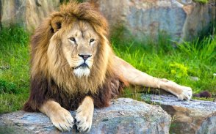
Source: http://www.animalsworlds.com/

AMPHIBIANS
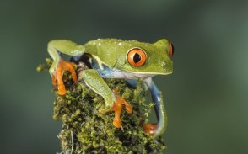
Source: http://www.animalsworlds.com/

The word amphibian means two-lives. Amphibians spend their lives in water and on land. The cold-_________________ animals like frogs, toads, salamanders, newts, and caecilians metamorphose or transform from a juvenile, water breathing form to an adult, air breathing form. Amphibians are four _____________ animals. They lay their eggs in water, just like their ancestors, the fish. They are similar to the reptiles. Amphibians are the animals with a backbone that existed on the earth. They belong to the kingdom Animalia and class vertebrates (meaning that they have a backbone or spine). Amphibians are further classified into three orders.

BIRDS
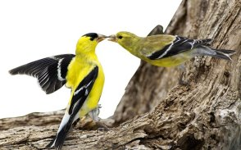
Source: http://www.animalsworlds.com/

Birds are the beautiful ________________ that can be seen all over the world. They can be seen in our houses and gardens nesting and feeding their young ones. It is so interesting to watch and observe the birds and to note their varying characteristics. Birds are warm-blooded; their body is streamlined and covered with ______________. Their forelimbs are converted into wings. Today about 9,703 species of birds live all over the globe and they are divided into 23 orders, and 142 families.

FISHES
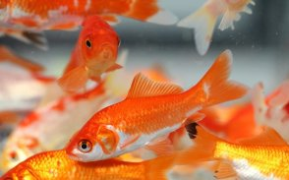
Source: http://www.animalsworlds.com/

Fishes are the oldest aquatic vertebrates found all over the world. Nearly 500 million years ago the first fish appeared on the earth and today fishes make up the largest group of vertebrates with 24,000 species. Their ______________ are lakes, streams, oceans, and estuaries. In 1991, it was estimated that 2546 species of fishes populated the world. Fishes are cold-blooded and they can’t control their body temperature. They have a good sense of taste, sight and touch, and are capable of living in both fresh and _______________ water.

REPTILES
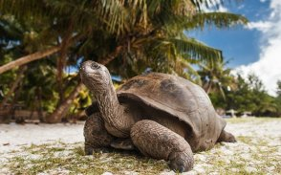
Source: http://www.animalsworlds.com/

The body of the reptile is covered with _________________ or they have a bony external plate called shell. Since the animals have the ability to creep, they got the name Reptiles (meaning to creep). Today there are about 6500 ______________ of reptiles recognised in the world. Those include crocodiles, snakes, lizards and turtles. The body structure of the reptiles is designed to make them adapt to survive both on land and in water. They are cold-blooded and can’t regulate their body temperature; they regulate it by adopting to the outside temperature. To keep them warm, they stay in the sun and to keep them cold, they stay in the water or hide under the ground or rock.

MAMMALS
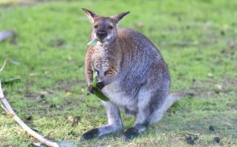
Source: http://www.animalsworlds.com/

Of all the classes in the animal world, the mammals are considered to be the most advanced and _______________ class. The animals in this class like cats, dogs, horses, and sheep have hair or fur and feed their young ones with the milk produced by the mothers. The human beings also belong to the class mammals.
Mammals have the capacity to adapt themselves to any type of environment including land, air and water. Mammals are warm-blooded animals; the presence of hair and fur on the body helps the mammals to maintain their body __________________ constant, because they react immediately to any difference in the temperature.

TASK 2 – Word formation
Read the text about the cat breeds and put the words in the brackets into the right form.

CAT BREEDS

(Adapted from: https://www.catological.com/ultimate-guide-cat-breeds-100-breeds/, https://www.petcarerx.com/article/the-most-common-cat-breeds/1199.)

Have you ever asked yourself exactly how many cat breeds are there?
With cross-breeding, new breeds coming up, and more, there are more than 100 types of cat breeds worldwide.

Whether exotic or plain, of long or short fur, of frisky or lazy temperament, there are a few cat breeds that are most ______________ (common) found in households. _____________ (adopt) and rescue are always recommended, and in most cases, your adopted kitty will not be purebred. If you do opt for a pedigreed cat, it is recommended that you look for a breed that matches your own _____________ (person) and temperament.

You will find the _____________ (present) of one of the most popular cat breeds in the world below.

MAINE COON
(Adapted from: https://www.petcarerx.com/article/the-most-common-cat-breeds/1199, https://www.slideshare.net/apoorvagupta12/maine-coon-cat.)

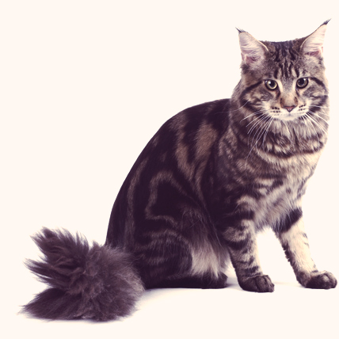
Behold the majestic Maine Coon. These gigantic furballs are native to the State of Maine and are one of the ____________ (old) natural breeds in North America. They are second largest breed among cats. They have a large bone structure with rectangular body.
Main Coons are quite _____________ (social) and amicable regardless of their looks. They are long-haired, with a distinctive __________________ (appear).Thus, they’ve been dubbed as “gentle giants”.

Source: https://cdn.petcarerx.com/LPPE/images/breedguidethumbs/Maine-Coon-cats-photo.jpg

An adult male Maine Coon can weigh up to 8.2 kilograms, whereas females can reach up to 5.4 kilograms. Excellent ____________ (hunt), susceptible to training and overall healthy, these creatures are valued among cat _____________ (own) from all over the world. Their sharp look makes them aggressive. They are vocal, playful and famous for getting along with other house pets, including canines. They love to spend a lot of time with their family. They cover their face with tail for ____________ (warm) in winter. Last, but not least, they mature slowly than other breeds and may not reach their maximum size before the age of three. Large and _____________ (play), but gentle and intelligent, Maine Coons are great with both children and dogs. Popular on farms, Maine Coons tend to follow their people around both inside and outdoors. ______________ (month) check-up should be done to avoid any type of disease. ______________ (screen) method is the best way to avoid hip disease.

TASK 3 – Listening and watching skills
Listen and watch the video clip on You Tube about Top 10 Domesticated Cat Breeds https://www.youtube.com/watch?v=m8RMv0tkwVk and decide what kind of feline friend you would have in your home.
Choose the one that you like best and explain something about its:
- behaviour,
- body type,
- popularity among people adopting it and
- the responsibility level of its owner.

TASK 4 – Comparing the pictures
Compare and contrast the following two pictures:
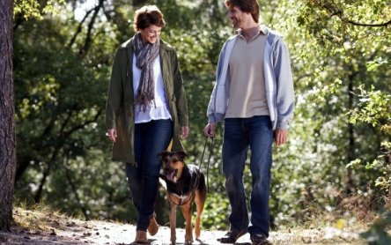
Source: https://vet-magazin.si/Znanost/mala-praksa/Sprehod-je-za-psa-veliko-vec-kot-le-zaposlitev.html

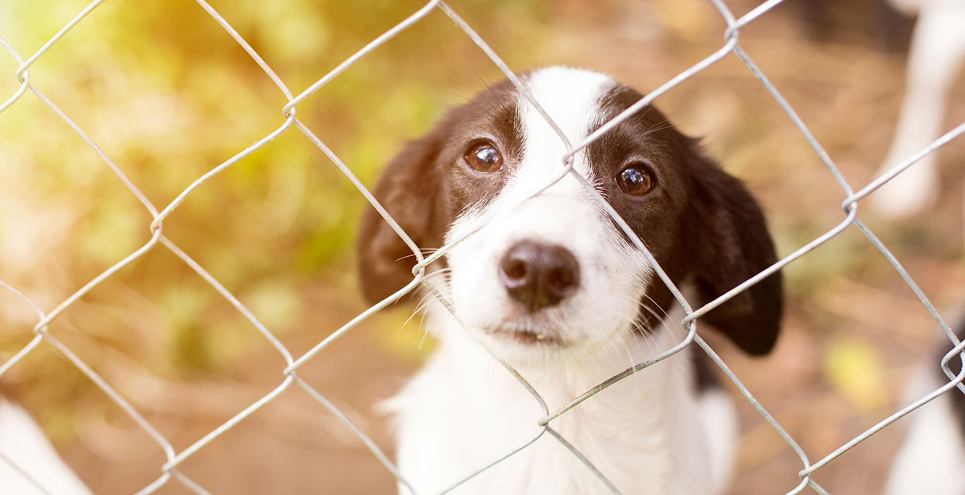
Source: http://www.triglavtek.si/Vsebovredu/home/druzina/po-psa-v-zavetisce

TASK 5 – Writing skills
Write an essay giving your opinion on the following statement:
We must stop animal abuse.

How far do you agree with this statement? Support your opinion in 160–180 words.

WE MUST STOP ANIMAL ABUSE
___________________________________________________________________
___________________________________________________________________
___________________________________________________________________
___________________________________________________________________
___________________________________________________________________
___________________________________________________________________
___________________________________________________________________
___________________________________________________________________
___________________________________________________________________
___________________________________________________________________
___________________________________________________________________
___________________________________________________________________
___________________________________________________________________
___________________________________________________________________
___________________________________________________________________
___________________________________________________________________
___________________________________________________________________
___________________________________________________________________
___________________________________________________________________
___________________________________________________________________
___________________________________________________________________
___________________________________________________________________
___________________________________________________________________
___________________________________________________________________
___________________________________________________________________
___________________________________________________________________

