A WONDERFUL WORLD
TASK 1 – Reading comprehension
Read the article on the wonderful world of nature and put the verbs in brackets into the correct tense. There are examples of active and passive sentences.

7 WONDERS OF THE WORLD

(Adapted from: https://www.victoriafalls-guide.net/7-wonders-of-the-world.html.)
There are undoubtedly some of the most amazing places on our planet but the seven natural wonders of the world ______________ (be) separated as the most awe-inspiring. These wonders of the world can _____________ (find) on five different continents and _____________ (be) magnificent in their natural beauty.

Victoria Falls
In Southern Africa, the Zambezi River flows across a flat plateau that ____________ (extend) hundreds of kilometres in all directions. It is here that one will find the largest waterfall in the world.
Victoria Falls is one of the wonders of the world, ____________ (stretch) 1.7 kilometres wide and ______________ (share) by the countries of Zambia and Zimbabwe. The falls _______________ (form) as the full width of the Zambezi River plummets into a 108 metre high cleft. During the wet season, the spray from the falls can ______________ (see) nearly 50 kilometres away, hence the local name Mosi-oa-Tunya (the ‘Smoke that Thunders’).
The falls drop into a deep, narrow chasm, which _____________ (connect) to a long series of gorges. This unique form _____________ (allow) the falls to be viewed face-on 60 metres away from the opposite side of the gorge.
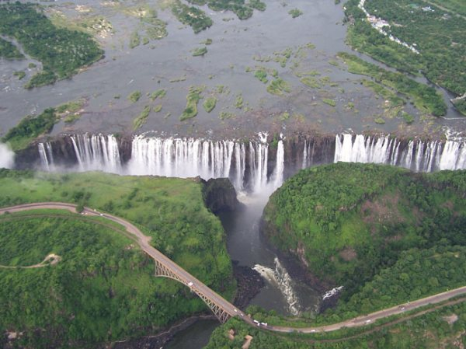
(Source: https://www.victoriafalls-guide.net/7-wonders-of-the-world.html)

Northern Lights – Aurora Borealis
Aurora Borealis (another one of the natural wonders of the world) ____________ (appear) in the North sky and is visible only from the Northern Hemisphere. These northern polar lights appear inadvertently from September to October and March to April. It ___________ (name) after the Roman goddess of dawn, Aurora and the Greek name for the north wind, Boreas. Often seen as a greenish glow or occasionally a faint red, the lights consist of solar wind and particles that appear as “curtains” or streamers _____________ (extend) in an east-west direction across the sky. The lights are constantly changing and evolving. The Cree call this phenomenon the “Dance of the Spirits.”
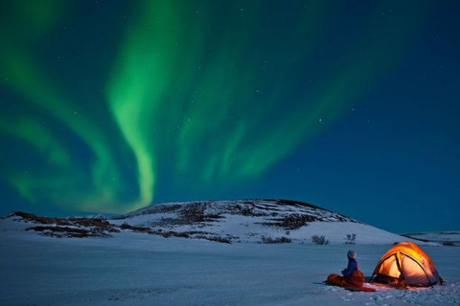
(Source: https://www.victoriafalls-guide.net/7-wonders-of-the-world.html)

Grand Canyon
Grand Canyon _____________ (locate) in North America and it is extending 400 kilometres through the Colorado Plateau in northwest Arizona. The canyon is 6 to 30 kilometres wide and 1.6 kilometres deep. The canyon is an erosion _____________ (form) by water, ice and wind and is considered one of the 7 wonders of the world. The layers of sedimentary rock ______________ (form) over millions of years ago and provide significant insight into the earth’s geologic timescale.
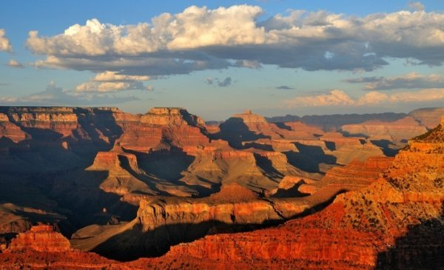
(Source: https://www.victoriafalls-guide.net/7-wonders-of-the-world.html)

Parícutin Volcano
In 1943 the Parícutin Volcano ___________ (erupt) in the state of Michoacán, Mexico. The first man to witness the eruption was a Tarascan Indian farmer, named Dominic Pulido. The Parícutin is a Monogenetic cone, which ____________ (mean) it stems from a single point of eruption. The volcano now ____________ (stand) at 410 metres above ground. Its hardened lava covers 16 square kilometres and its volcanic sand covers 32 square kilometres. Named after a small Tarascan Indian village, Parícutin is now counted as one of the seven wonders of the world.
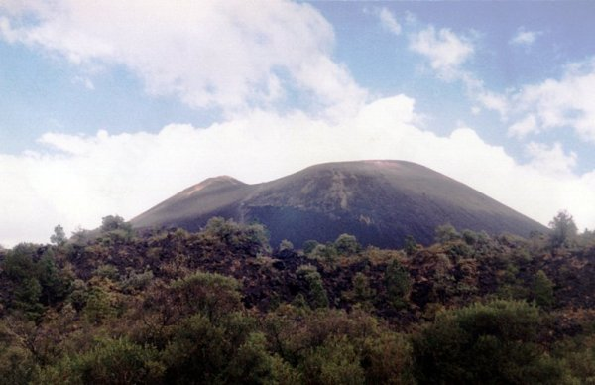
(Source: https://www.victoriafalls-guide.net/7-wonders-of-the-world.html)

Harbour of Rio de Janeiro
The Harbour of Rio de Janeiro in Brazil is one of the 7 wonders of the world because it holds many illusions. The Harbour can _____________ (view) in so many ways that it _____________ (appear) differently and can be deceptive. For example, the mountains create an entrance into the bay and can make it appear to be a lake. However, when the Portuguese explorers _____________ (arrive) in 1502, they believed the bay ______________ (be) a large river and ______________ (name) it Rio de Janeiro, the “River of January,” in honour of the month they arrived.
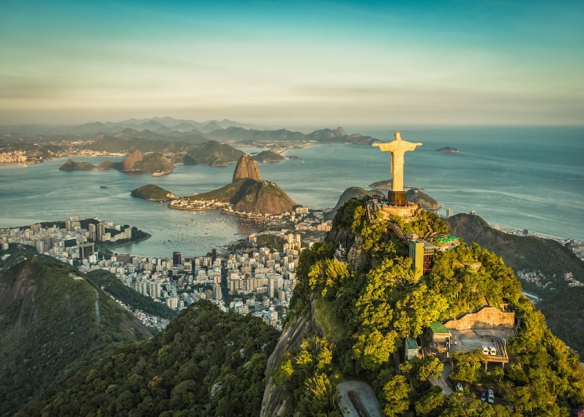
(Source: https://www.victoriafalls-guide.net/7-wonders-of-the-world.html)

Mount Everest
On the edge of the Tibetan Plateau stands one of the most impressive of the 7 world wonders, the mountain called Mount Everest. Like the rest of the Himalayas, Mount Everest _____________ (rise) from the floor of the ancient Tethys Sea. It ________________ (consider) to be the highest mountain in the world and continues to grow today at the rate of a few millimetres each year. Mount Everest and the Himalayas were traditionally revered by the local people as the homes of the gods and _______________ (consider) sacred.
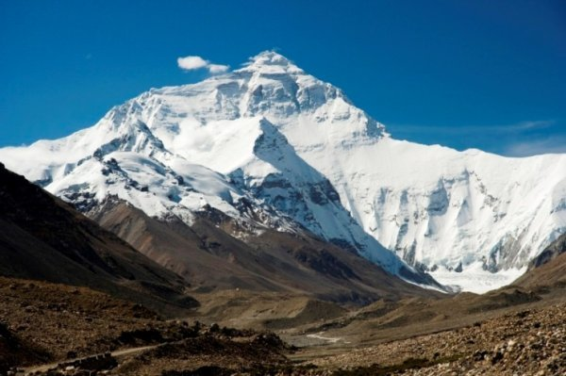
(Source: https://www.victoriafalls-guide.net/7-wonders-of-the-world.html)
Great Barrier Reef
The last of the 7 wonders of the world is the Great Barrier Reef along the northeast coast of Queensland, Australia. The Great Barrier Reef _____________ (stretch) 2,600 kilometres and _____________ (be) the world’s largest coral reef ecosystem ________________ (compose) of 2,900 individual reefs. It supports a variety of vulnerable and endangered species. The Great Barrier Reef covers an area of approximately 344,400 square kilometres and is the only living organism on earth that is visible from space.
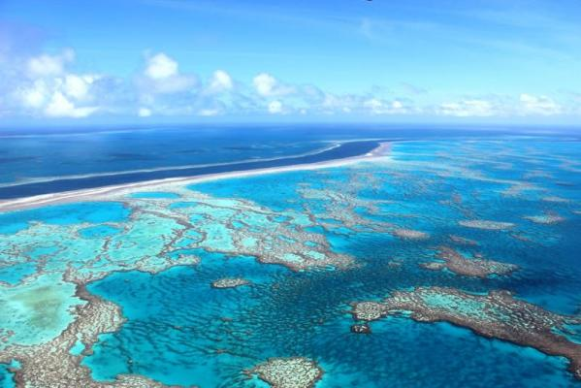
(Source: https://www.victoriafalls-guide.net/7-wonders-of-the-world.html)

TASK 2 – Word formation

Read the following articles on seven wonders of the modern world and complete it with the right forms of the words in brackets:
LIST OF THE SEVEN WONDERS OF THE MODERN WORLD

(Adapted from: https://www.wonders-of-the-world.net/Seven/List-of-the-seven-wonders-of-the-modern-world.php.)

The list of seven modern wonders was established by the New Seven Wonders Foundation, a private _____________________ (organise) having nothing to do with UNESCO.

This list was designated following a vote organized by the New Seven Wonders Foundation, foundation created by the _____________ (Switzerland) businessman Bernard Weber linked to a private marketing company. It is therefore a private initiative with a mercantile goal, having _____________ (absolute) nothing to do with UNESCO, which is often credited with the project.

If we can see a commercial will behind this foundation, there is no doubt that the organizers had a will to highlight the world heritage. The criteria chosen for the final _______________ (choose) were the aesthetics of course, but also the _______________ (complex) of implementation in the historical context, that is, the fact that the architects of the time were able to build it despite the limited opportunity they had to do so. Another criterion was the historical interest of the monument. All technical exploits carried out for aesthetic or cultic purposes, such as skyscrapers or hydraulic dams, monuments that were too recent. Of the 177 files presented, only 21 were retained, for 7 winners. One out of three therefore. The results were announced on 7 July 2007 in Lisbon.

___________________ (USE) OF SUCH A LIST
The ________________ (establish) of a new list of the seven wonders of the world seems a mercantile _______________ (operate), although participating in the _________________ (improve) of world heritage. It has nevertheless made it possible to better publicize this heritage and that is enough reason to have done so. The beneficiaries are thus the countries, and indirectly the tourist sites, where these marvels are located.

The great contest was launched at the time of the 2000 Olympic Games in Sydney. From this day anyone who wanted to vote could send an SMS (overtaxed) or make a phone call (also surcharged) to a voice server that recorded the vote. Each could vote twice, one per SMS the other by telephone. Such a system is inevitably ______________ (risk): Countries with large populations are likely to have a better chance of seeing their monument than small countries, especially if the population has a standard of living that would allow them to have mobile phones. It is therefore hard to see how Jordan was able to get the city of Petra to be selected, whereas the United States did not obtain the statue of Liberty.

And this is due to the ______________ (politics) powers of the various countries which did not hesitate to set up voting systems by automated servers, voting becoming free, the cost of the call being taken care of by the State. In _______________ (add), Brazil, for example, has carried out a massive publicity campaign to make its people aware of the ________________ (important) of having Christ the Redeemer on the list, which inevitably favoured him. In France the Eiffel Tower did not benefit from such popular enthusiasm.

THE _________________ (COMPETE) SITES
The 21 files filed were all of high quality. There was a bit of everything like type of monuments. Some were from the _____________ (industry) era, such as the Statue of Liberty or the Eiffel Tower, others represented an _____________ (architecture) ensemble such as the city of Timbuktu or the Kremlin, a real city in Moscow, some were more classical (The Alhambra, Sydney Opera House, St. Sophia Basilica) and three of them were ancient monuments, the Acropolis of Athens, Stonehenge and the Moai of Easter Island. One can imagine that the acropolis has been dismissed for its too close proximity to the ancient wonders in relation to which it is younger in a short time, but it is ____________ (sure) more for its proximity to time and place because Stonehenge, for example, is much older.

WINNERS
The Great wall, Beijing (China)
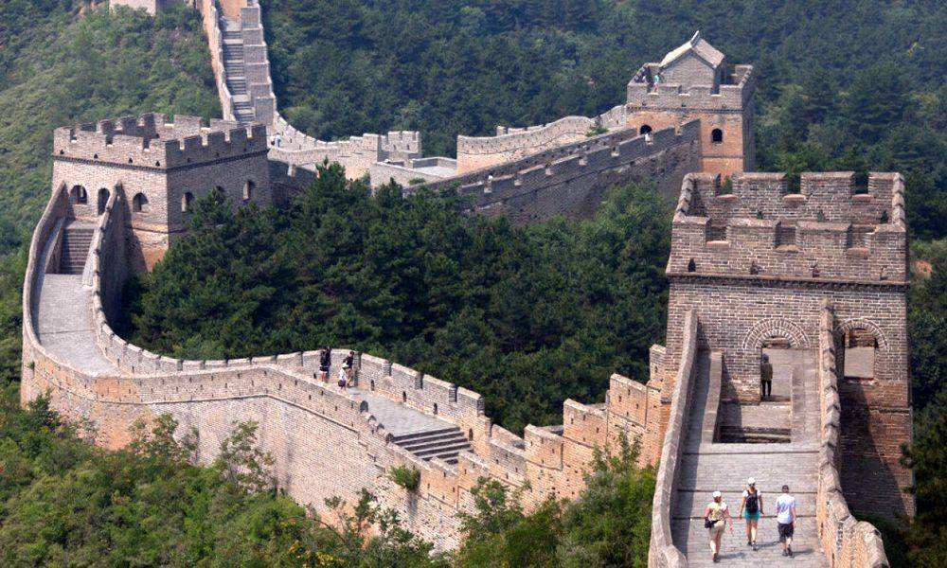
(Source: https://www.wonders-of-the-world.net/Seven/images/Modernes/Grande-muraille-de-Chine.jpg)

The city of Petra, Petra (Jordania)
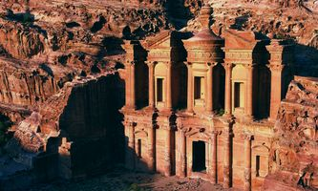
(Source: https://www.wonders-of-the-world.net/Seven/images/Modernes/Petra.jpg)

Christ the Redeemer, Rio de Janeiro (Brazil)
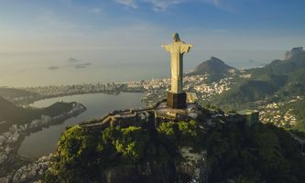
(Source: https://www.wonders-of-the-world.net/Seven/images/Vignettes/Modernes/Christ-redempteur-V.jpg)

The Machu Picchu, Cuzco (Peru)

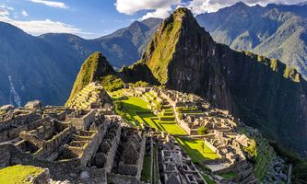
(Source: https://www.wonders-of-the-world.net/Seven/images/Vignettes/Modernes/Machu-Picchu-V.jpg)

Chichen Itza, Valladolid (Mexico)
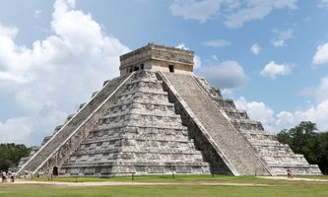
(Source: https://www.wonders-of-the-world.net/Seven/images/Vignettes/Modernes/Chichen-Itza-V.jpg)

The Colosseum, Roma (Italy)
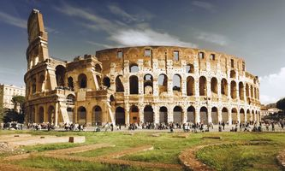
(Source: https://www.wonders-of-the-world.net/Seven/images/Vignettes/Modernes/Colisee-de-Rome-V.jpg)

Taj Mahal, Agra (India)
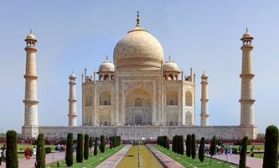
(Source: https://www.wonders-of-the-world.net/Seven/images/Vignettes/Modernes/Taj-Mahal-V.jpg)

TASK 3 – Listening skills

What a Wonderful World was written in 1968 during the time of the Vietnam War. Performed in the genre of jazz, it was written and composed to try and bring hope to the millions of victims suffering the effects of the war like the loss of the many loved fathers, sons and husbands and the “half cast” children who were sent away from their Vietnamese mothers to a foreign land with foreign people.

Listen to What a Wonderful World by Louis Armstrong and fill in the missing words.

https://www.youtube.com/watch?v=CWzrABouyeE

WHAT A WONDERFUL WORLD – LYRICS
I see __________ of green, red roses too
I see them ___________ for me and you
And I think to myself what a wonderful world
I see ___________ of blue and clouds of white
The ___________ blessed day, the dark sacred night
And I think to myself what a wonderful world
The ____________ of the rainbow so pretty in the sky
Are also on the ___________ of people going by
I see friends _____________ hands saying how do you do
They're really saying I love you
I hear ____________ crying, I watch them grow
They'll learn much more than I'll never ___________
And I think to myself what a wonderful world
Yes I think to myself what a wonderful world

TASK 4 – Speaking skills

When speaking about different wonders of the world, you are now asked to present ideas of the wonders of the modern world – the inventions.

Why are new inventions important?

Make a list of the modern inventions that have changed the world.

Present advantages and/or disadvantages about each one.

TASK 5 – Writing skills
Write an essay giving your opinion on the following statement:
Wonders are many, and none is more wonderful than me.

How far do you agree with this statement? Support your opinion in 160–180 words.
WONDERS ARE MANY, AND NONE IS MORE WONDERFUL THAN ME
___________________________________________________________________
___________________________________________________________________
___________________________________________________________________
___________________________________________________________________
___________________________________________________________________
___________________________________________________________________
___________________________________________________________________
___________________________________________________________________
___________________________________________________________________
___________________________________________________________________
___________________________________________________________________
___________________________________________________________________
___________________________________________________________________
___________________________________________________________________
___________________________________________________________________
___________________________________________________________________
___________________________________________________________________
___________________________________________________________________
___________________________________________________________________
___________________________________________________________________

